**Top Menu**



* Height and line height should be 56px
* Use the background color for header
* .light-theme.ant-pro-layout .ant-layout-header.ant-pro-layout-header {
* background: linear-gradient(90deg, rgba(1, 40, 51, 1) 0%, rgba(1, 101, 130, 1) 55%, rgba(0, 143, 172, 1) 100%) !important;
* }

**Side Menu**

* Width 220Px
* Every menu should need to have an appropriate icons
* As icons are getting from user-management need to keep all your svg icons in **all-svg-icons** file
* For SVG Icons you can use any websites like <https://iconscout.com/>
* 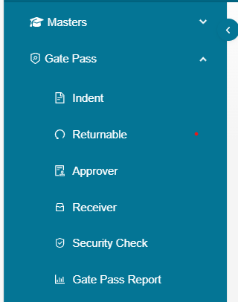

**Body**

* first and far most point for body is you should always try to utilize only (90Vh) of the space to show all you data without scroll
* so always use cards and tables with small size which will reduce the un-necessary space utilization
* let’s take example of a table with medium

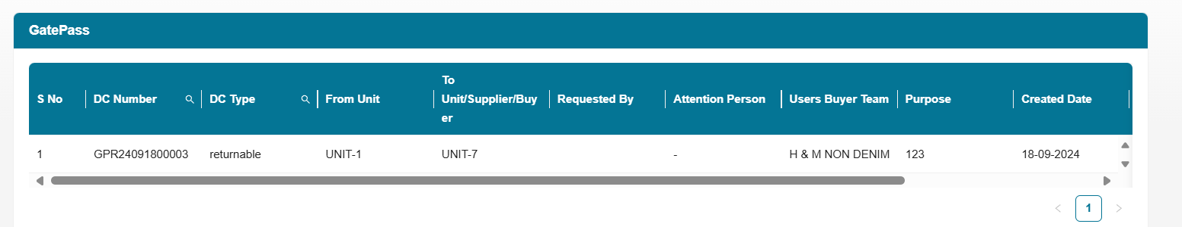

and small

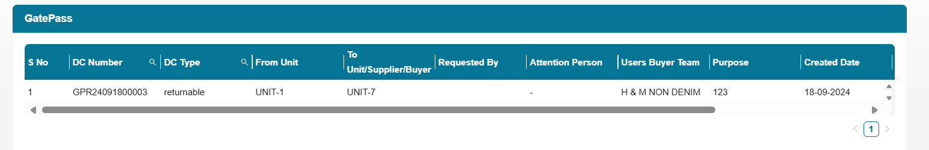

When you compare both when you use the small table it increased not only it’s look

It also advantage to end user because he can see two more records without scrolling

* **event triggering elements like buttons(create,edit,delete,exports) should always be inside the view port** 
  + because he need to get attention like he needs to perform an action there like approving or editing or something because we are giving CRUD model so with glance of first sight he should identify where those CRUD elements are

**Let’s take an example here at first I am not able to identify where to start editing or how can I see the detailed view when I scroll to right than only I got to know the action items**

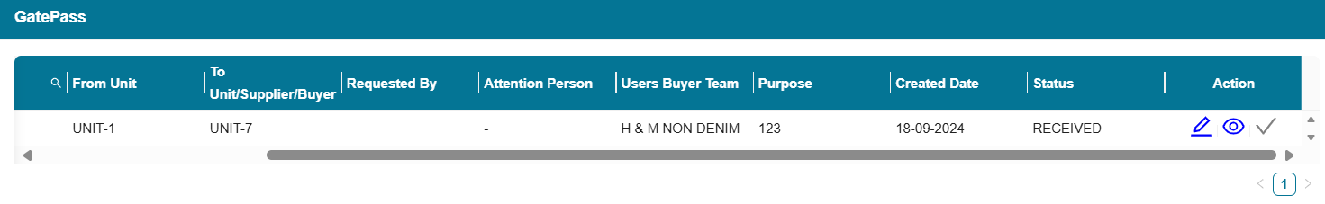

Here we are able to show the actions on first time itself so for actions always use **fixed right and also we can use actions like shown below**

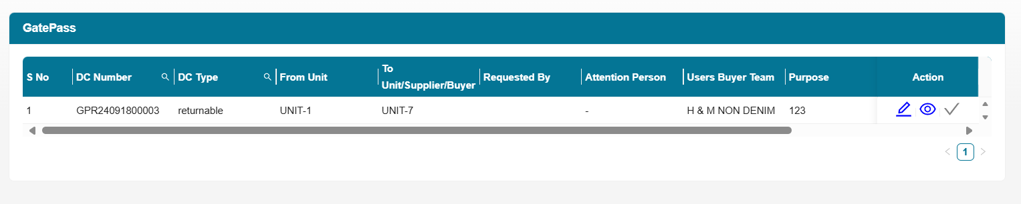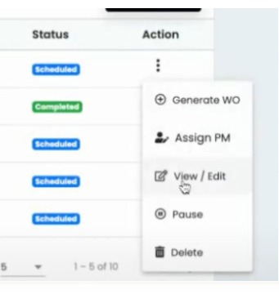

* **By using side filters we can show large data set by utilizing the space**

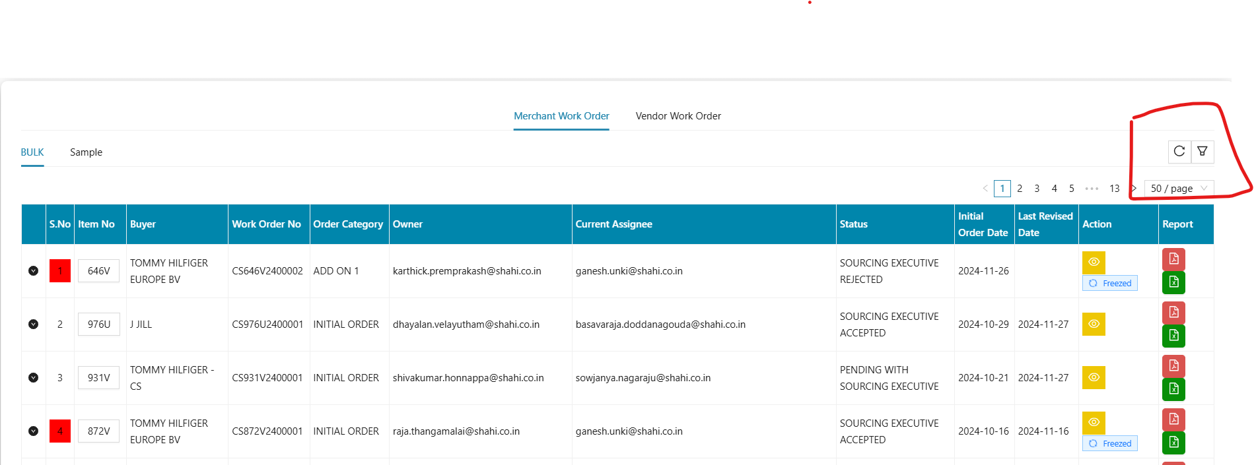

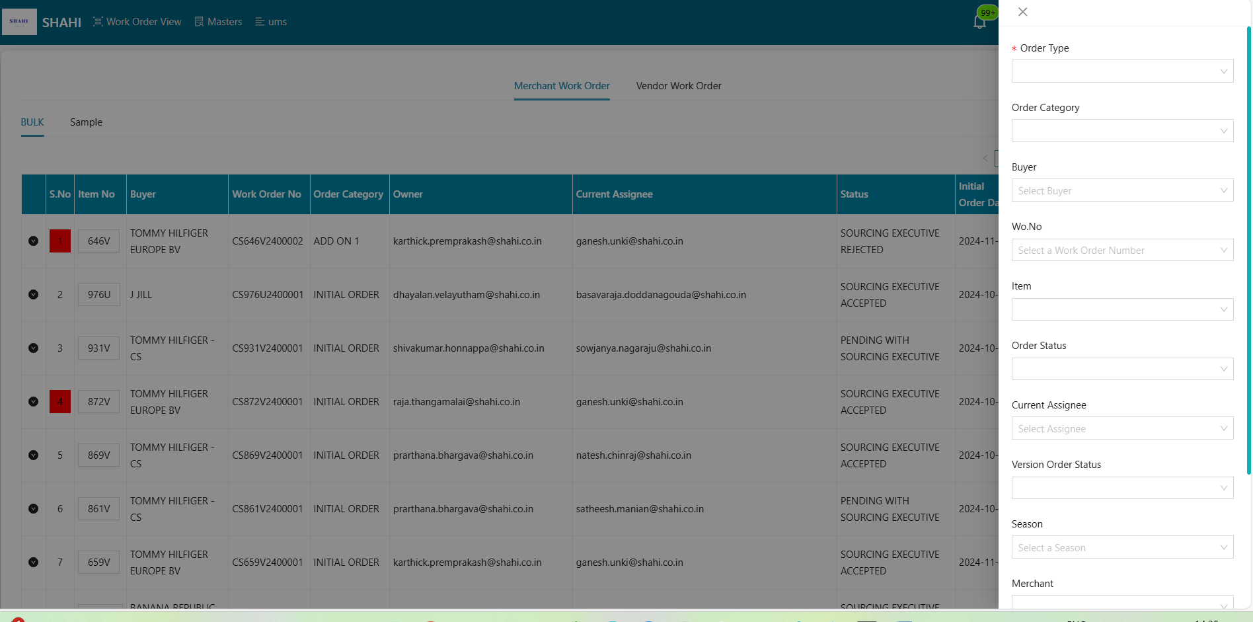

* **When there is a flow of actions to perform you need to use Flow Form as shown below**

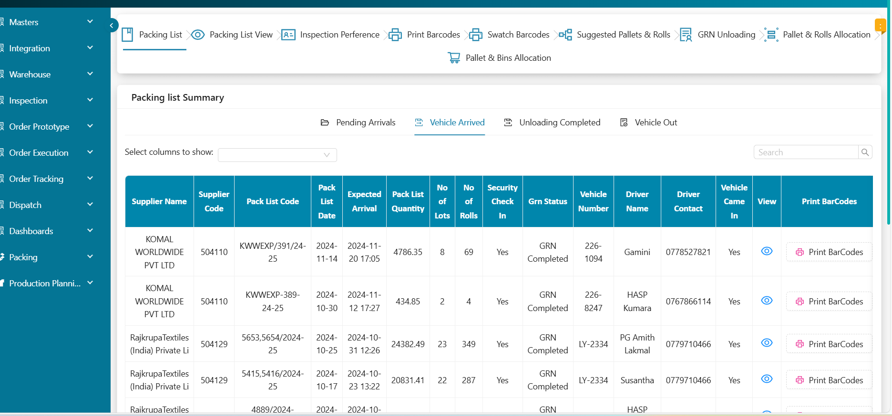

**Table**

Use text align center for text items in table column, Text align right for Number (Amount, Quantity)

Use Freez column for Action items and main columns (headers also)

For lots of column and rows in the table make it like excel view (Remove padding for tds, table scrolling with fixed height)

Add some tag component for differentiate column values

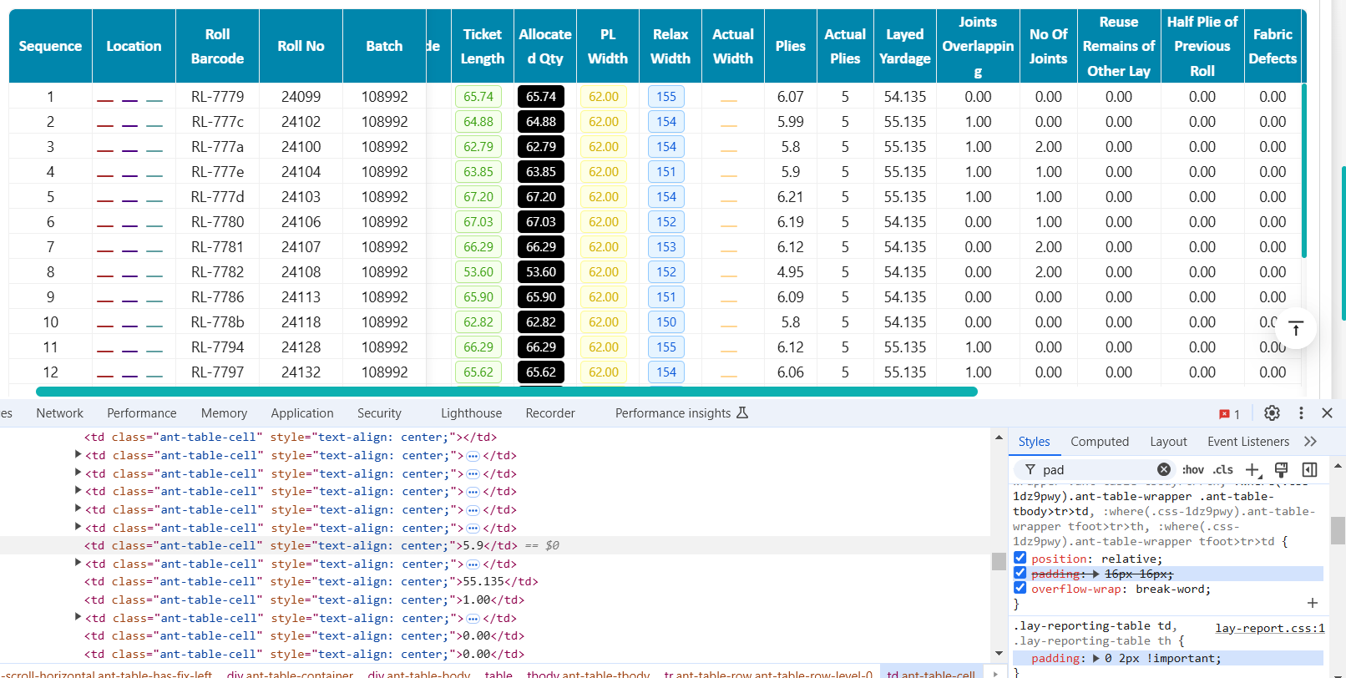

**With padding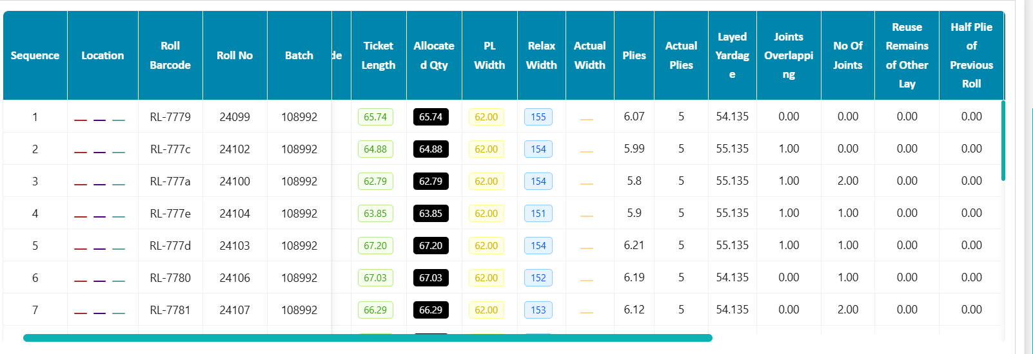 With Out padding**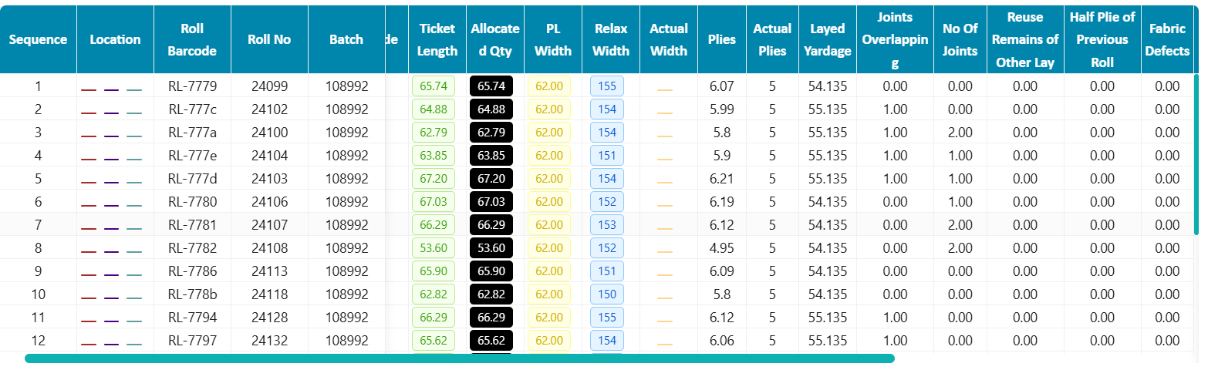

**Remove border and padding input in tables. Check the Actual Plies in below screen shot**

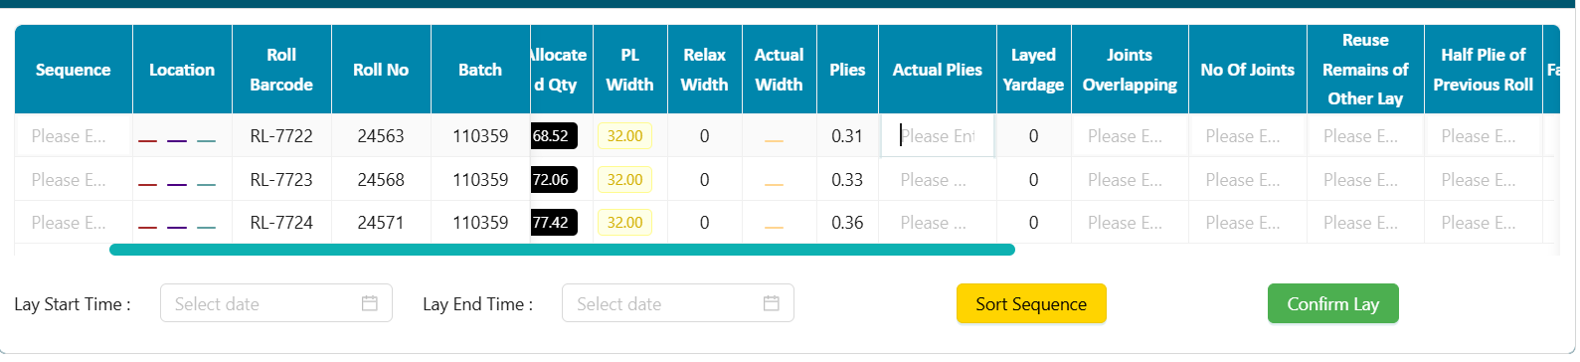**With Borders**

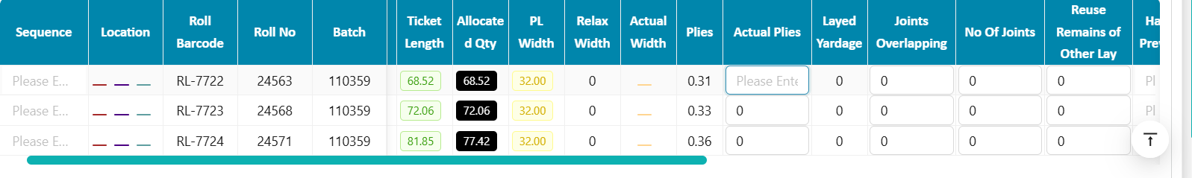

Use scroll to top float buttons

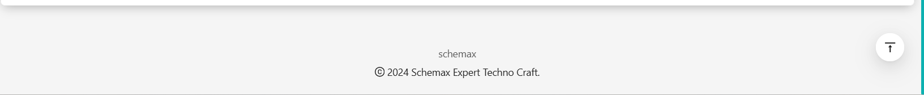

**Use Tabs with different color icons . Use collapse for header level information**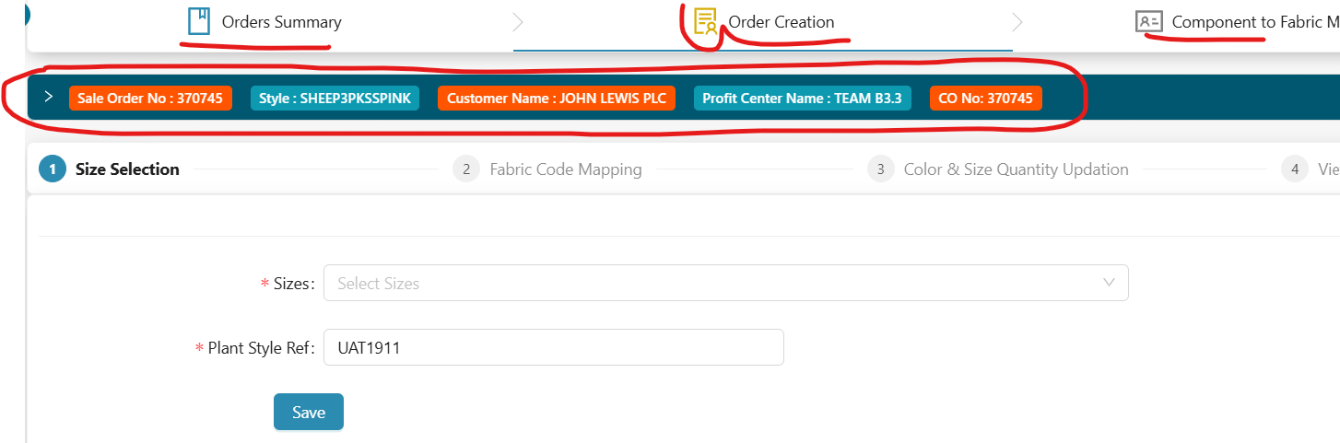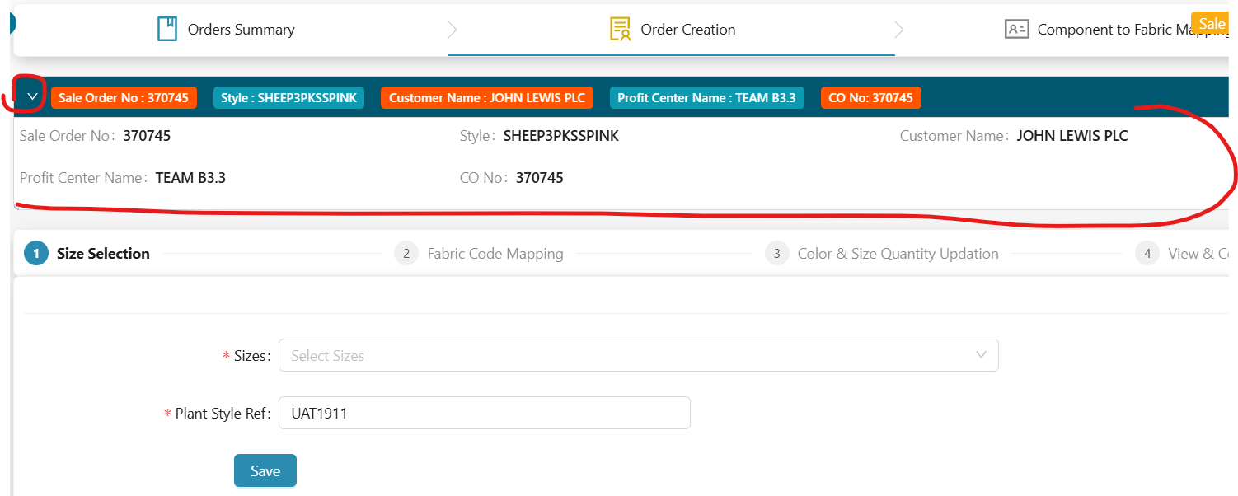

**Add Some color boxes to identify easily for status**

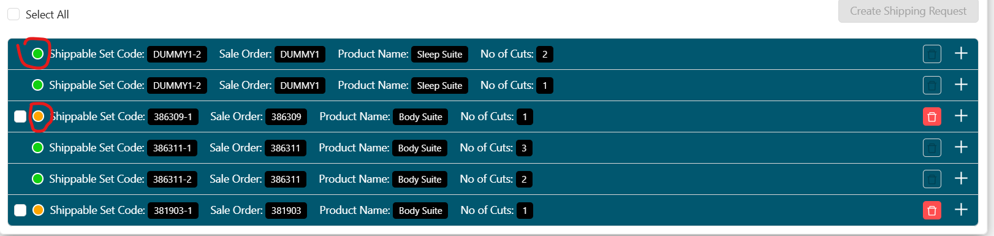

**Add different color buttons for different actions**

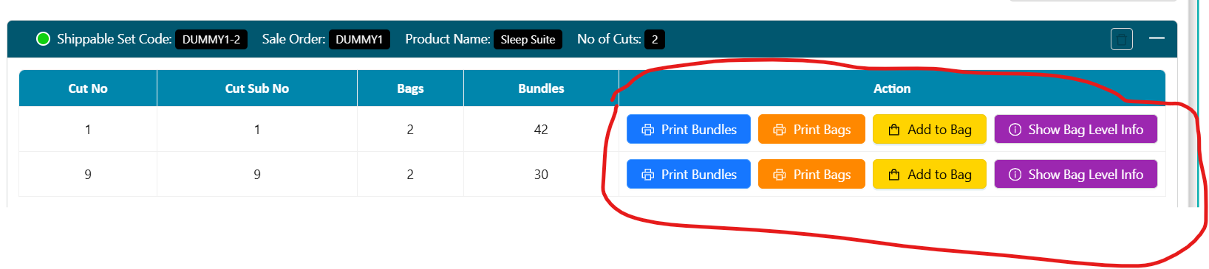

/* Custom styles for the default button state */

.btn-orange {  background-color: #ff8800 !important;  border-color: #ff8800 !important;   color: #fff !important;}

/* Custom styles for the button when hovered */

.btn-orange:hover {  background-color: #ffaa33 !important;  border-color: #ffaa33 !important;  color: #fff !important;}

/* Custom styles for the button when active/pressed */

.btn-orange:active {  background-color: #dd6600 !important;  border-color: #dd6600 !important;}

.ant-btn-primary.btn-orange:disabled, .ant-btn-primary.btn-orange.ant-btn-disabled {

  cursor: not-allowed;  border-color: #d9d9d9 !important;  color: #a4a4a4 !important;  background-color: #e2e2e2 !important;  box-shadow: none;}

Search and View : Primary Color

Submit and Update : Green (#4caf50)

Delete and Remove : Use Danger (Red)

Other actions : Orange and Yeelow(#ff8800 , #ffd400)

**Some Sample dashboard designs , Use these kind of colors ,icons for dashboards (https://themesbrand.com/velzon/html/master/dashboard-job.html)**

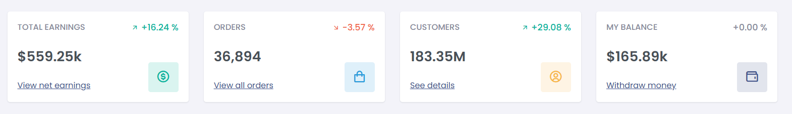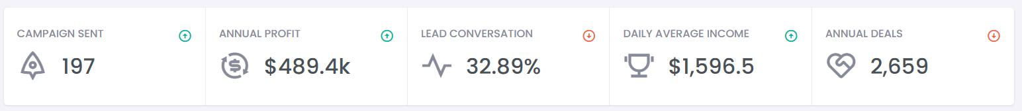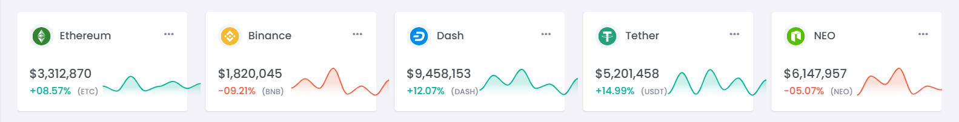

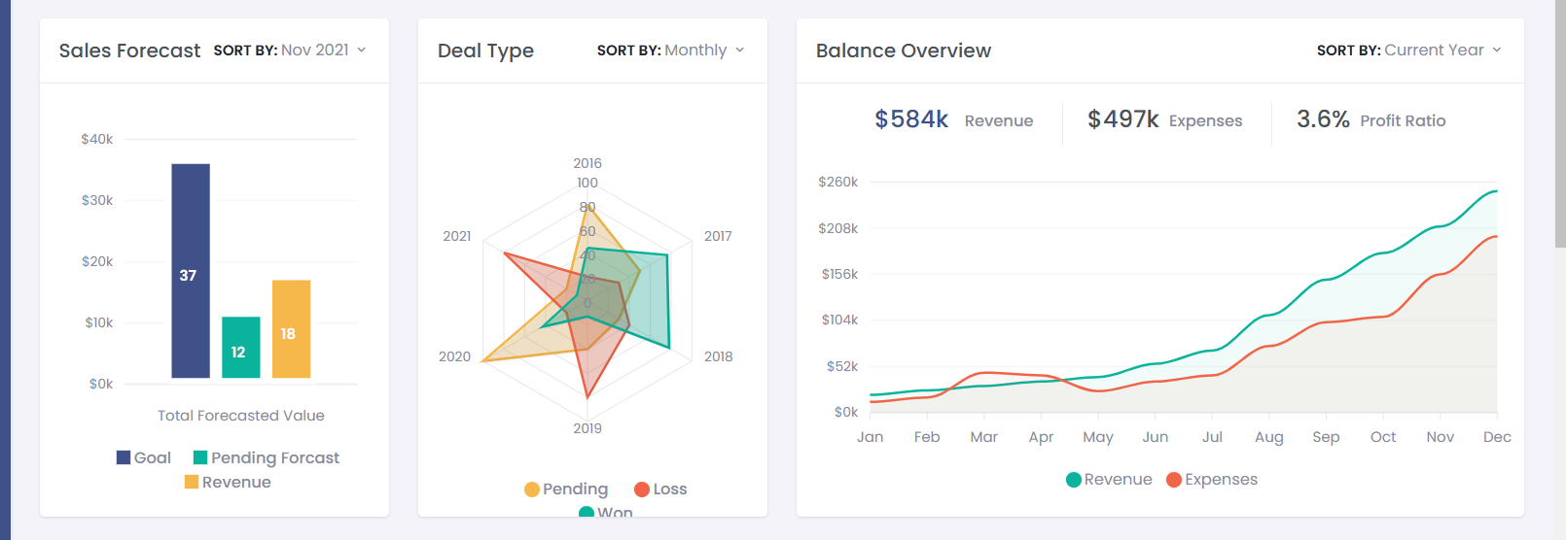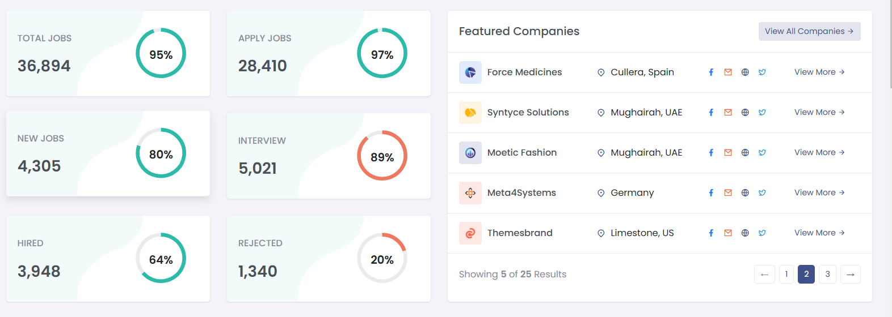

* Use antd token to modify any styles for existing components like cards or tabs collapses and all so that we can modify easily
* 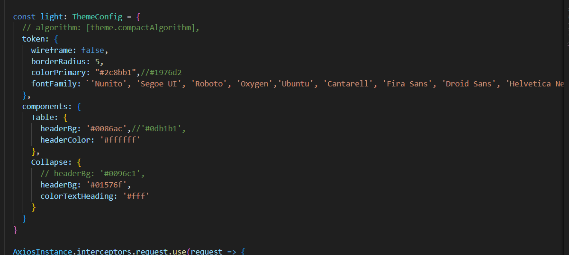
* For charts use Antd Plots <https://ant-design-charts.antgroup.com/en>
* Always use subtle color shade instead bright and saturated.
* For tables, make sure the Product ID/Name(**against which he is showing data**) or any other is fixed while scrolling.
* Try to keep the box-shadow between 0.1 and 0.2 use this - ( box-shadow: 0 4px 8px rgb(0,0,0,0.1) )
* When going for a responsive website don’t encourage inline styling (unless it’s necessary, or it makes sense) , always keep a CSS file.

**Finally one thing and one rule is you need to be the best criticizer to your task and best end user than only you can get best outcome**