1. **Login Page:**

* In order to have access to the website, type in the following page.
* **URL:** **http://dev.schemaxtech.in/#/**

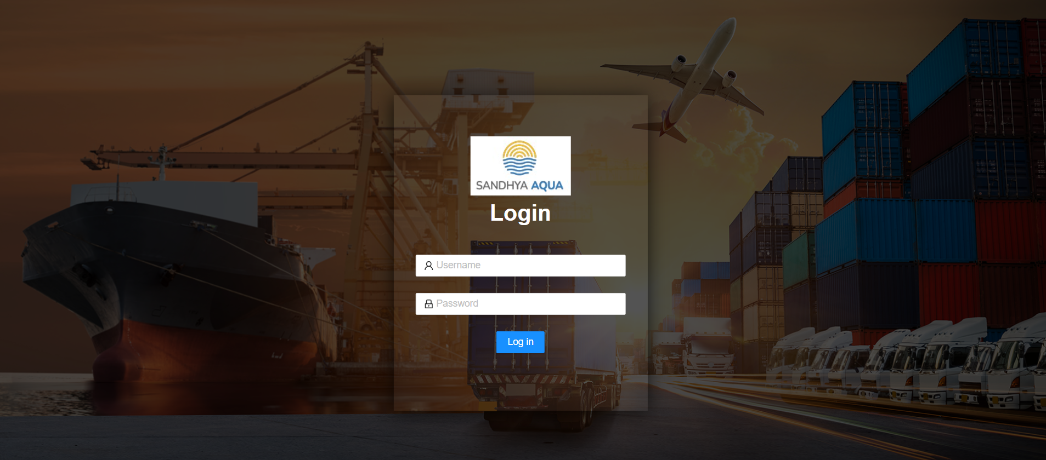

* When you click on the link http:// dev.schemaxtech.in/#/ you will be directed to the above pasted screen shot. To have further access you must login using user name and password.

**2. Layout:**

* After login, you will be directed to the below pasted screen

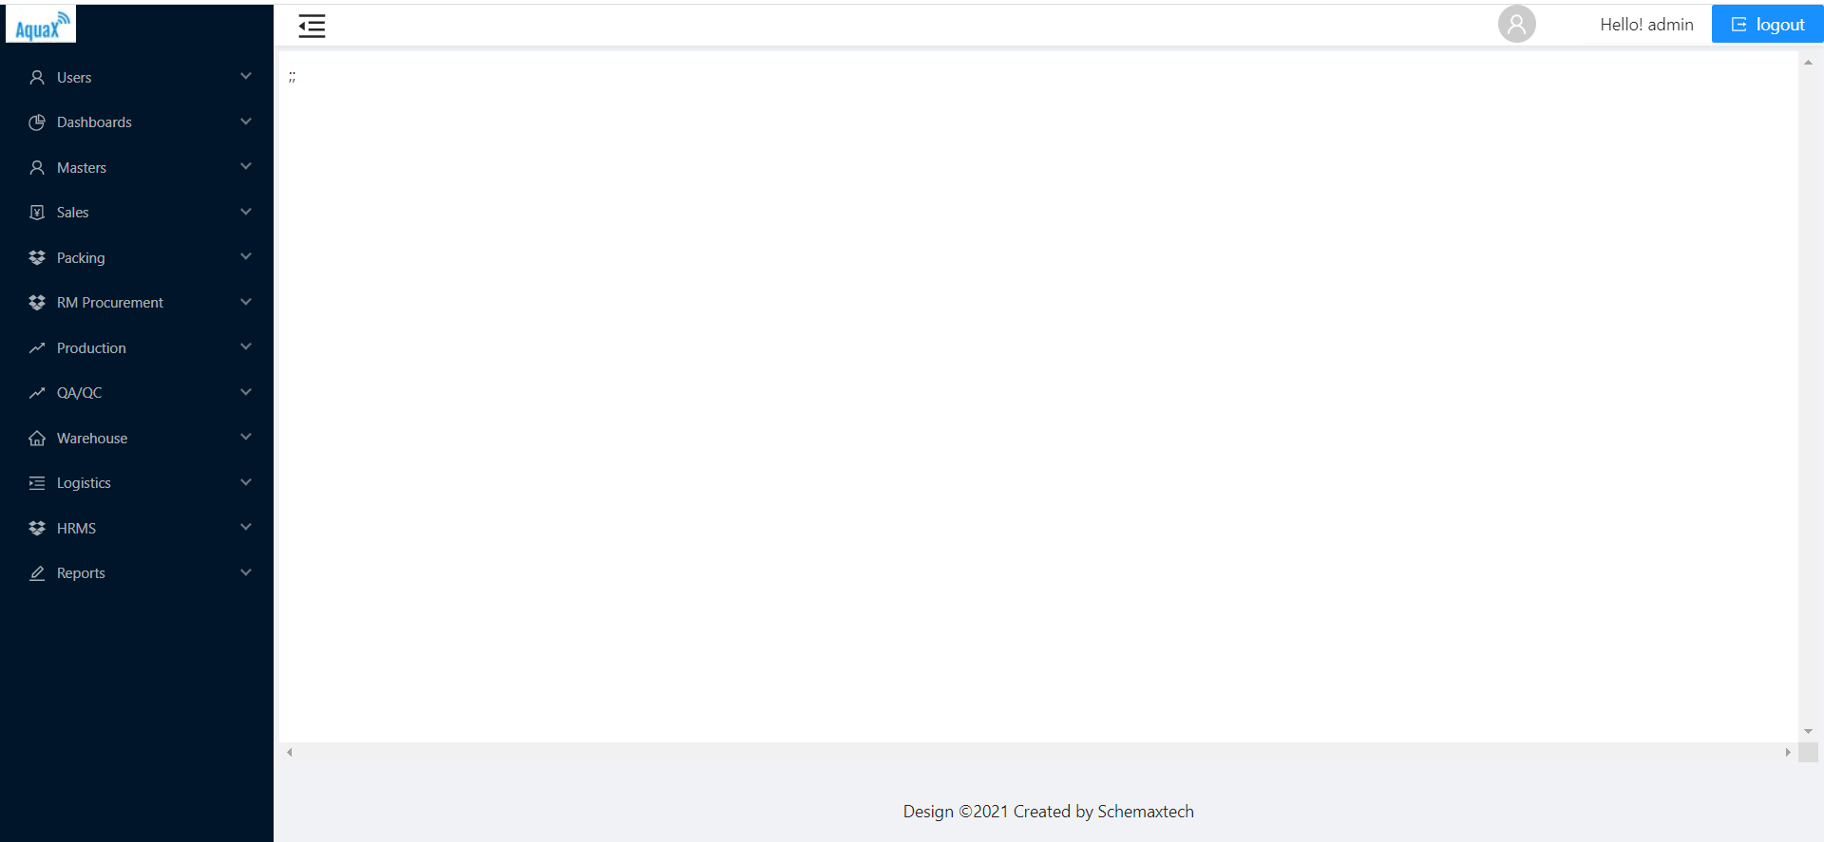

* The is the first page which shows all the modules which are used in the project

**3. User module:**

* In this page we can see all the users details and we can find either they are active or in active, and roles of certain employee.
* Here we can find the total number of users and how many are active and in active

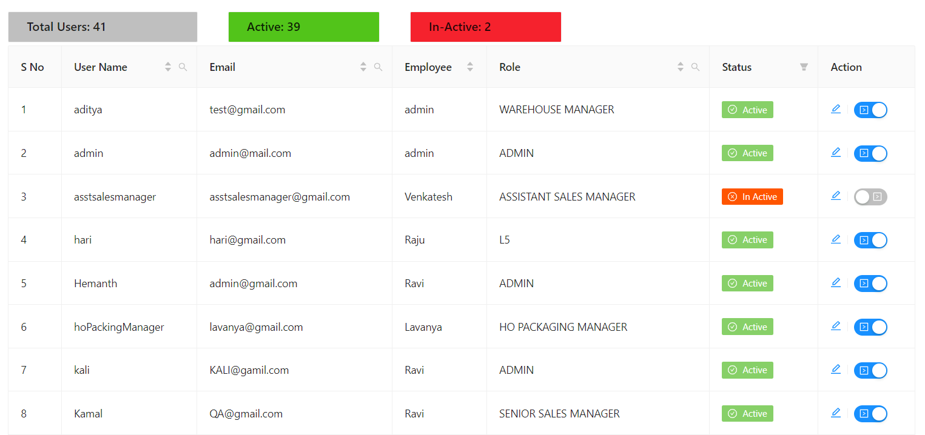

**4. Masters:**

* + - The use if master is globally used all over the projects.
    - We will use this when we have some fixed values
    - They can be used throughout the project.

**Global:**

* The components we will use in this is all about the general topics which can be use all over the project
* The data cannot be repeated or used more than one time in a master.
* Here are some masters that we have in this “GLOBAL” sub module is certification, countries, destination etc.,

Just like “Global” we have so many sub modules in the masters. Each module will have the data which are referred to that particular module.

Now, let us see what all the modules we have in our masters are “Global, Sales, Raw Materials, Transportation, Packing, Warehouse, Planning, Production, QA QC, HRMS” are the sub modules which we will find in the master’s module.

**4. Sales:**

**1) SO Creation:**

The order is placed here. To place the order, they required Customer details such as Names, Sale Order Id, Purchase Order Id etc., Product Details, Certification, Packing Details, Lab Inspection, QA/QC Inspection are the details which we need to fill in the Creation of the sale order.

**So Process type:**

MTO: - Is a business production strategy that typically allows consumers to purchase products that are customized to their specifications.

MTS: - is a manufacturing strategy in which production planning and production scheduling are based on forecasted product demand.

**So type:**

When we will select “MTS” then so type will only be in stock. This means when we will get the stock then we will do the basic needs to be done for the stock and store it in freezer. Then when we will get the order then we will repack the stock and transfer the order.

**ETD:** Estimated time of Departure

**ETA:** Estimated Time of Arrival.

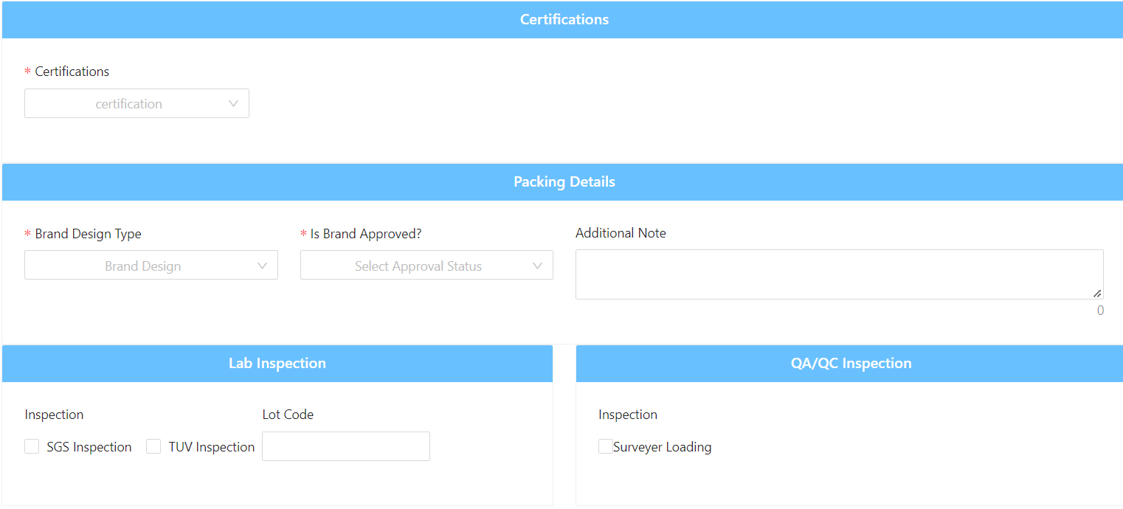

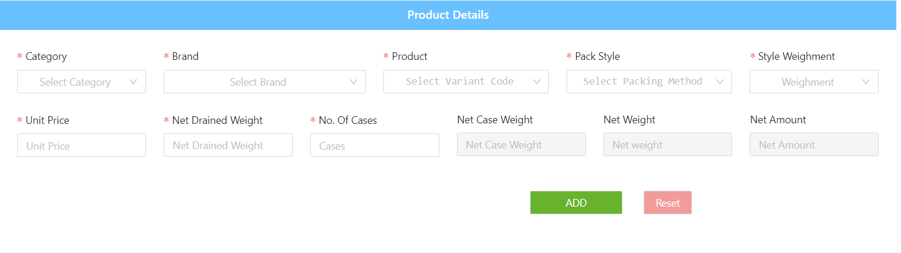

**2) SO Tracker:**

* Here we can track the order, which we have created previously.
* We can search the order using the SO order, unit name, date and destination details of the sale order.

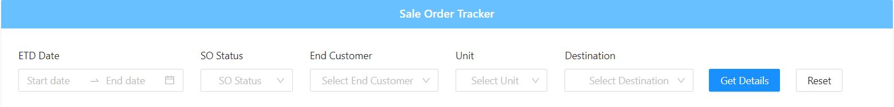

* There after we will find all the sale orders with their details.

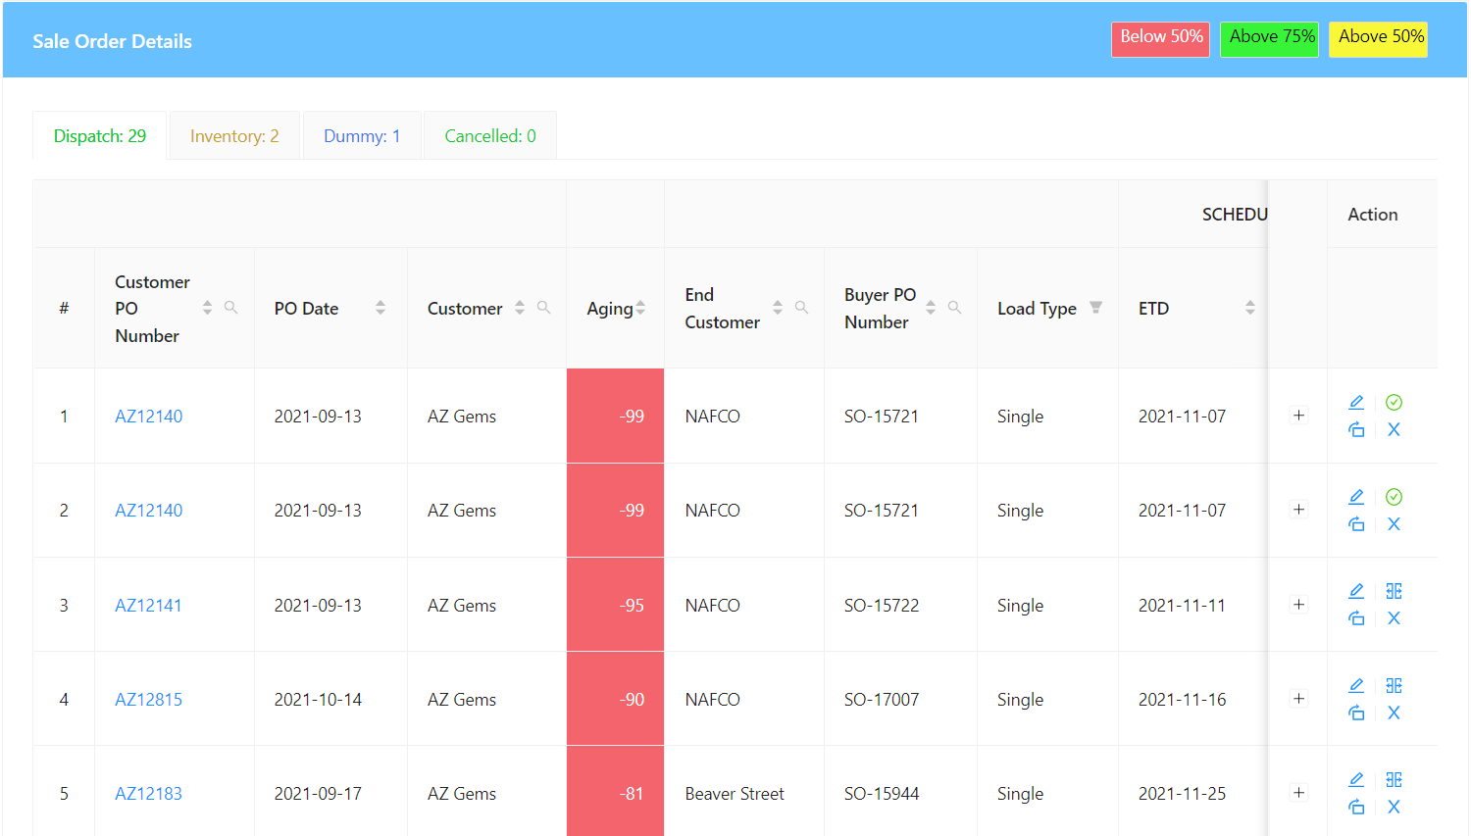

* Here we can see all the orders with required details in the grid.

**5. Packing:**

**1) BOM tracker:**

* The full form of BOM is Bill of Materials. This is important source of information for manufacturing concerns.
* This contain all the details like number of items required such as items received, assigned, available.

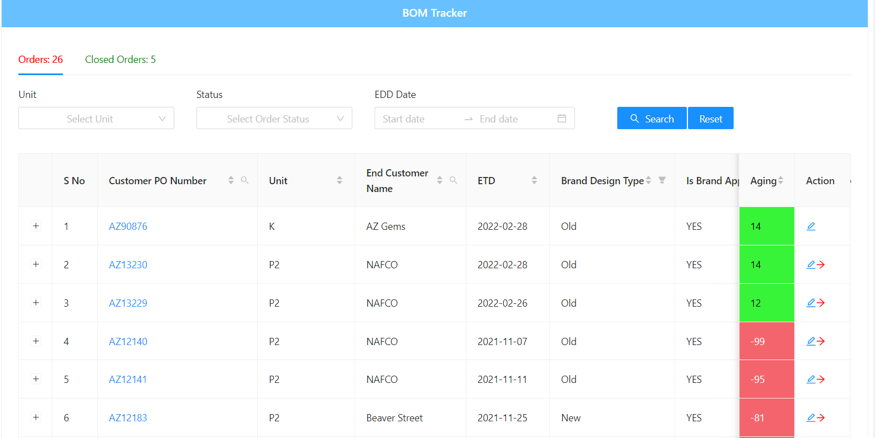

* The above one is the list for all orders and the below one is in detailed about each sale order

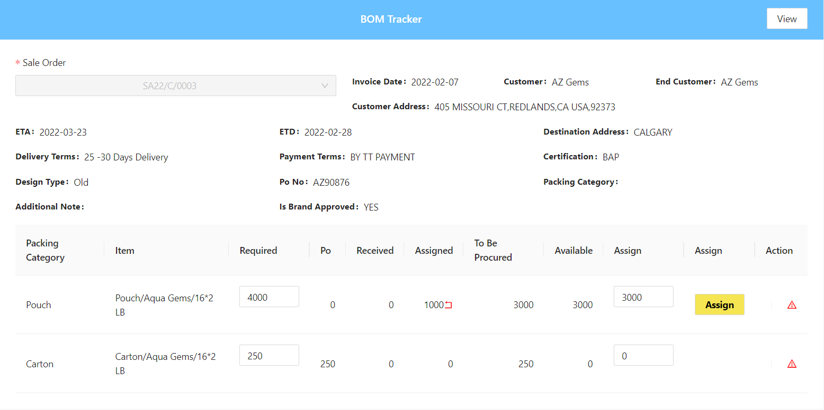

**2) Packing BOM:**

* We can find the full details of all sale order. We can search the full details of the sale order using unit, So order, customer name and item name.
* Using this we can find our required sale order. Here, we can see all the orders in all plants

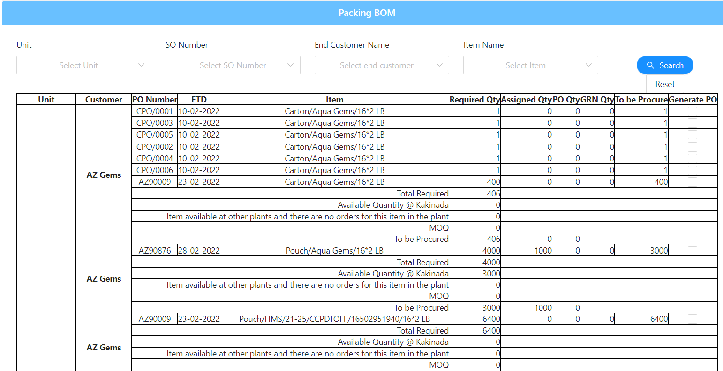

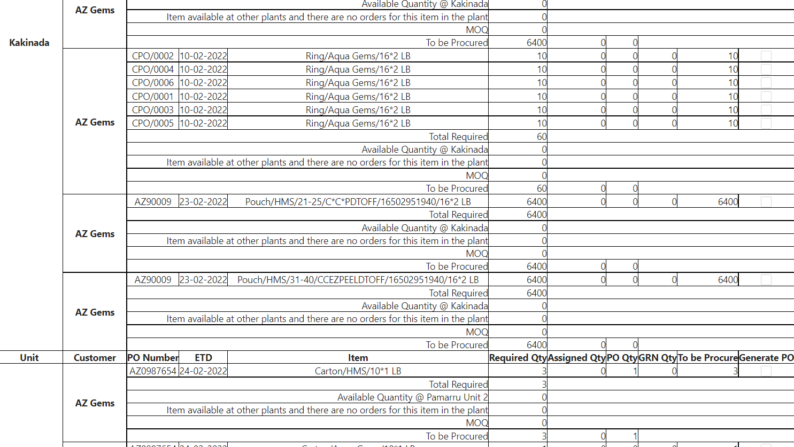

**3) PO:**

* This screen is to create a new order. If needed, we can create purchase order or we can use the old sale order to create a new purchase order.

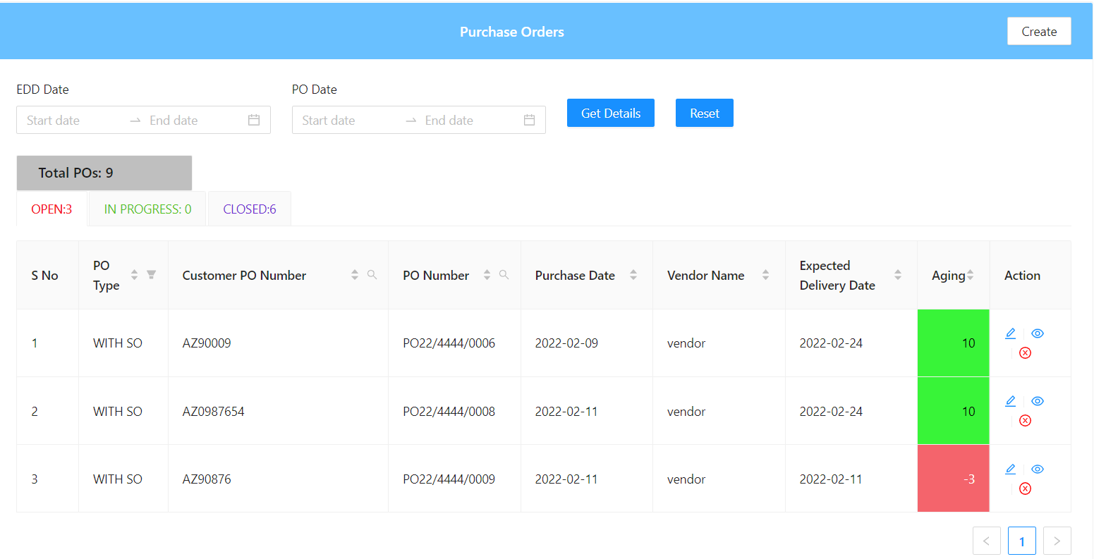

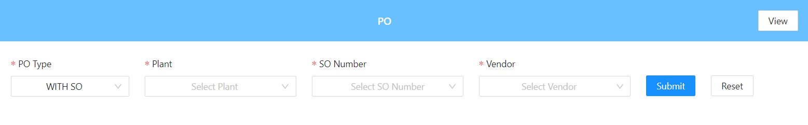

**4) GRN:**

* GRN is a record of goods received from suppliers, and this record is shown as the proof.

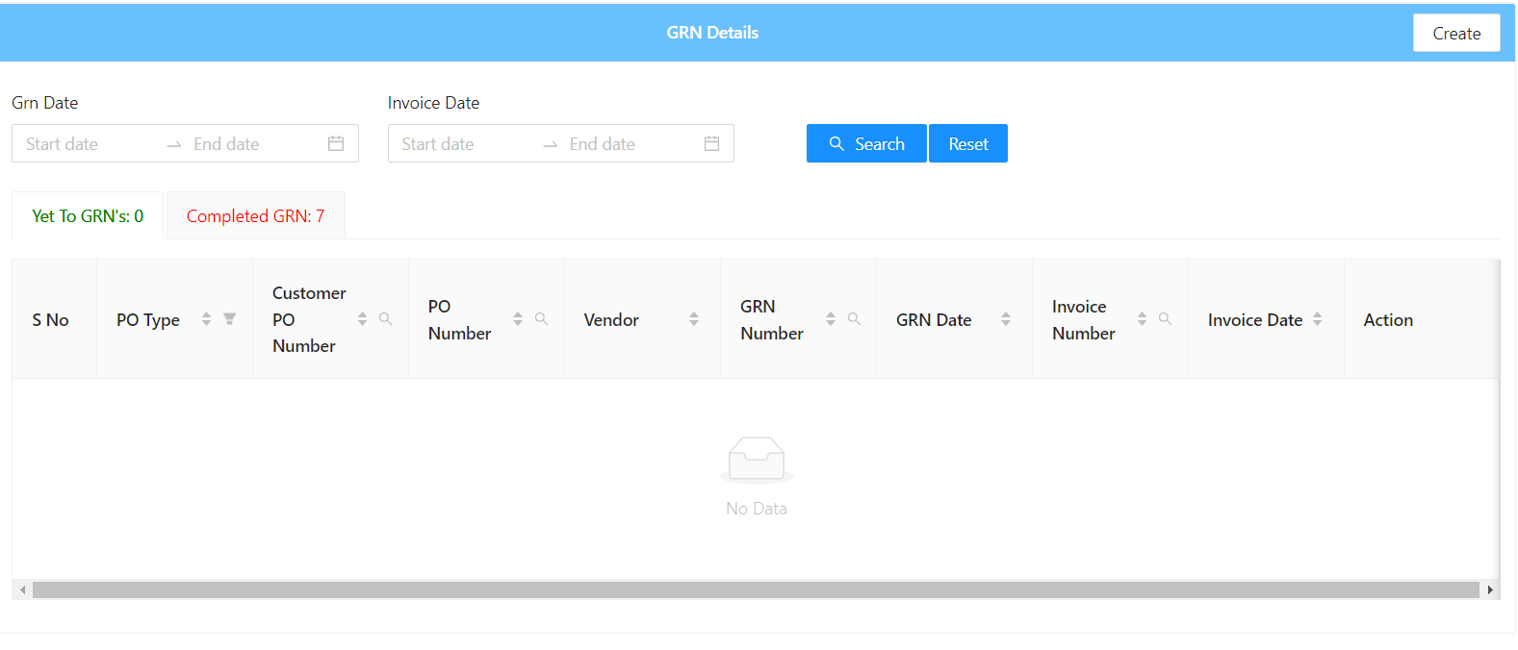

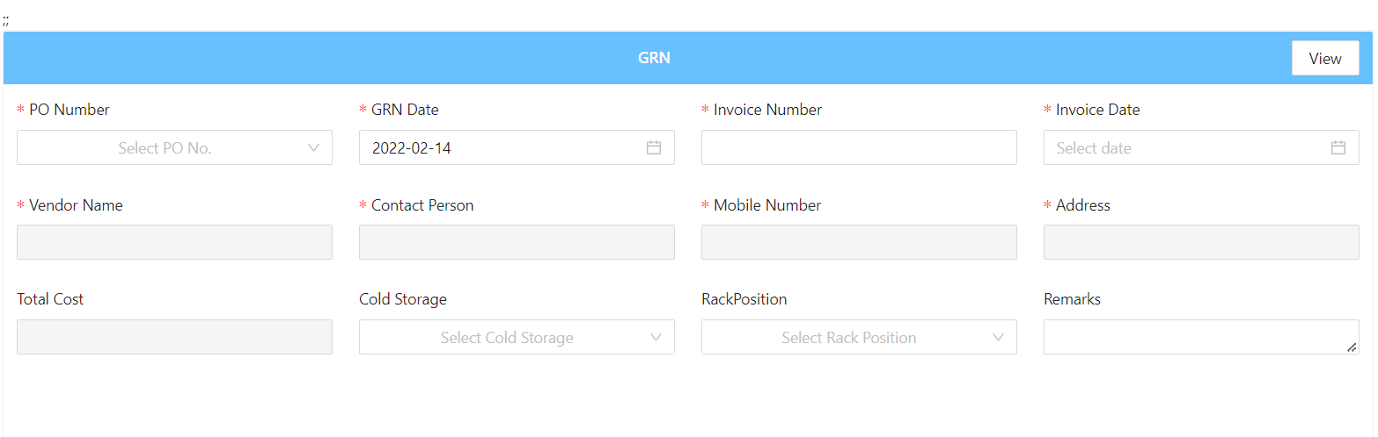

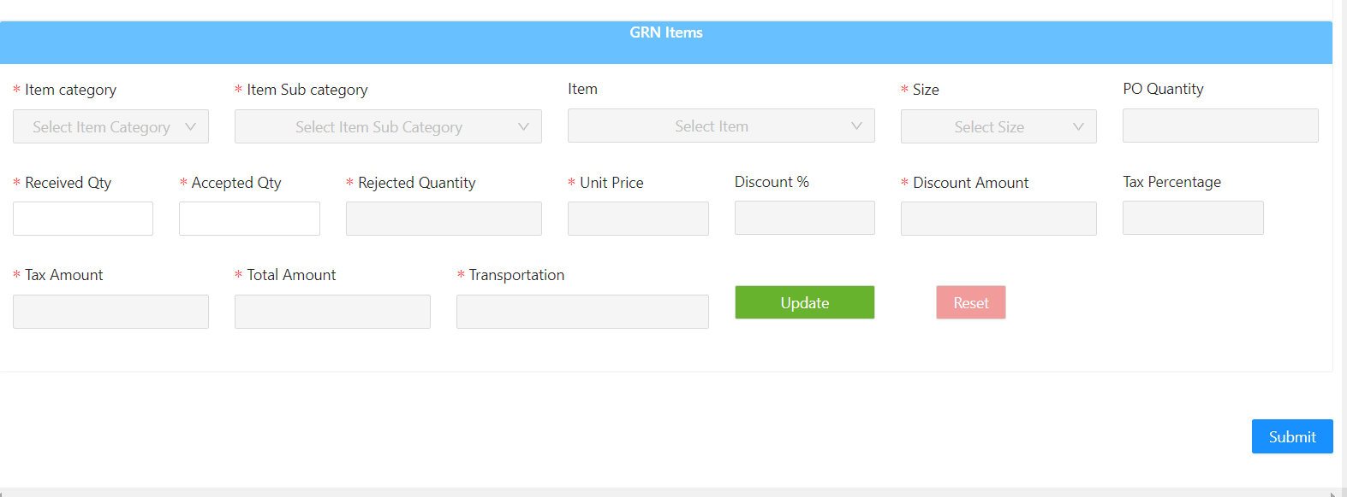

**5) GRN Return:**

* If we have any issue with the product, then we will return it.
* Then we will take the GRN number to return the items which we did not like it.

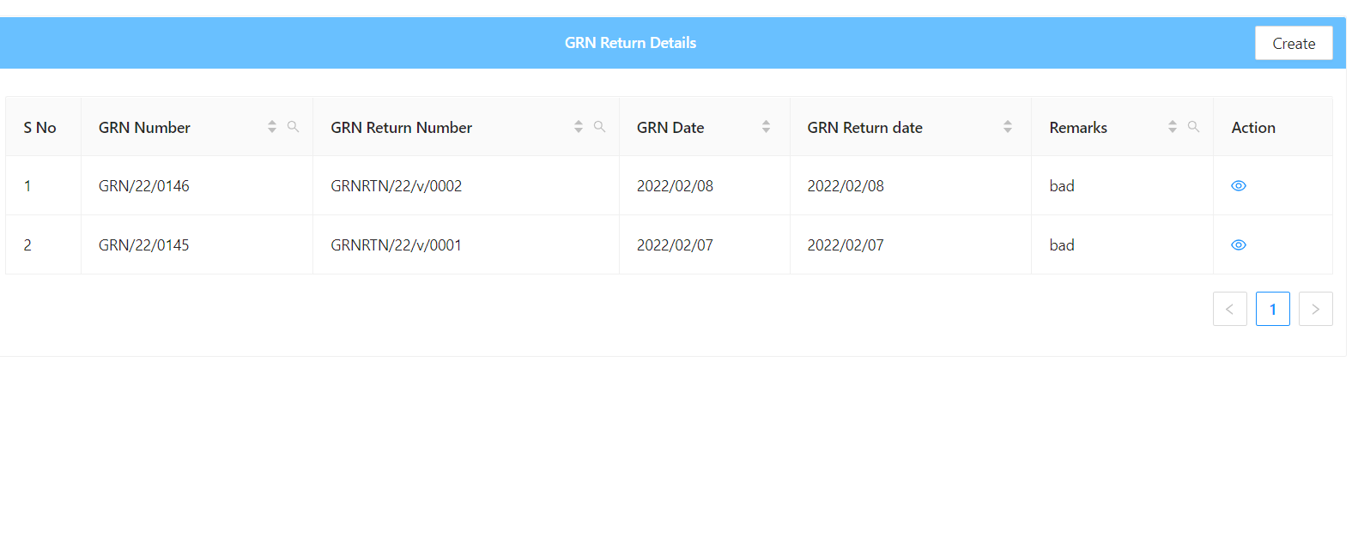

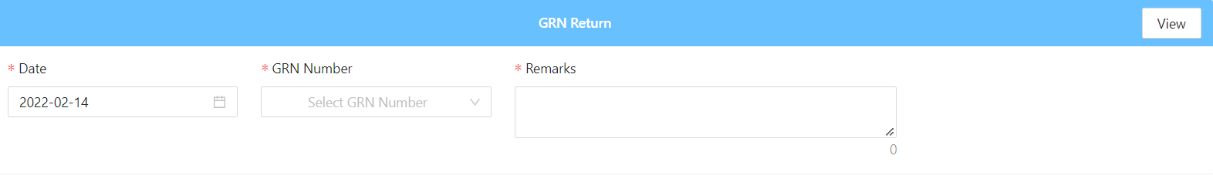

* If we will select the GRN number, then we will the full details of the GRN number and how many orders are placed previously for the same name.

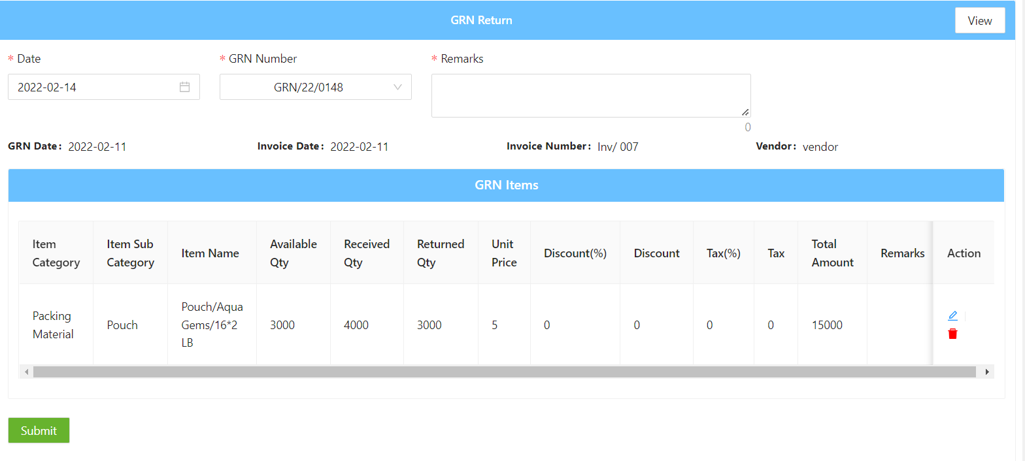

**6) Stock:**

* Here we will know all the details of the stock that we have.
* And check whether it is SO Inventory and Bulk Inventory.

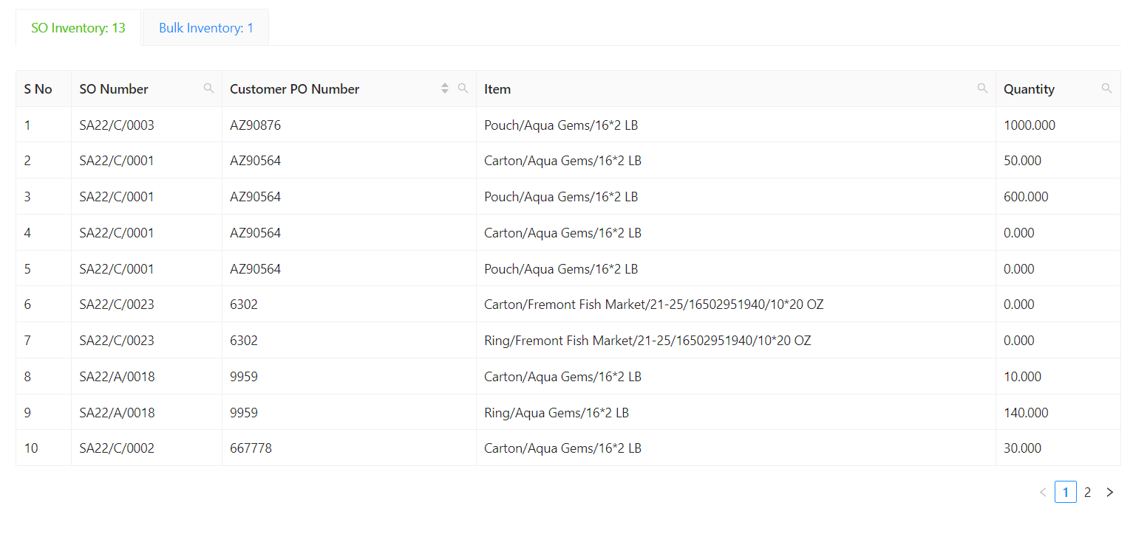

**7) Stock Transfer:**

When the stock gets transfer then with the help of the Against So for the transfer of stock.

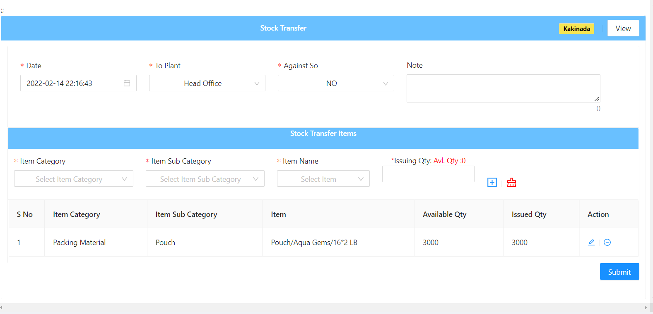

**8)Stock Issue:**

* When we will find an issue in the stock that we received.
* And we need to mention how much we consumed from the total stock that we have.
* We will just inform them what are the issues here.

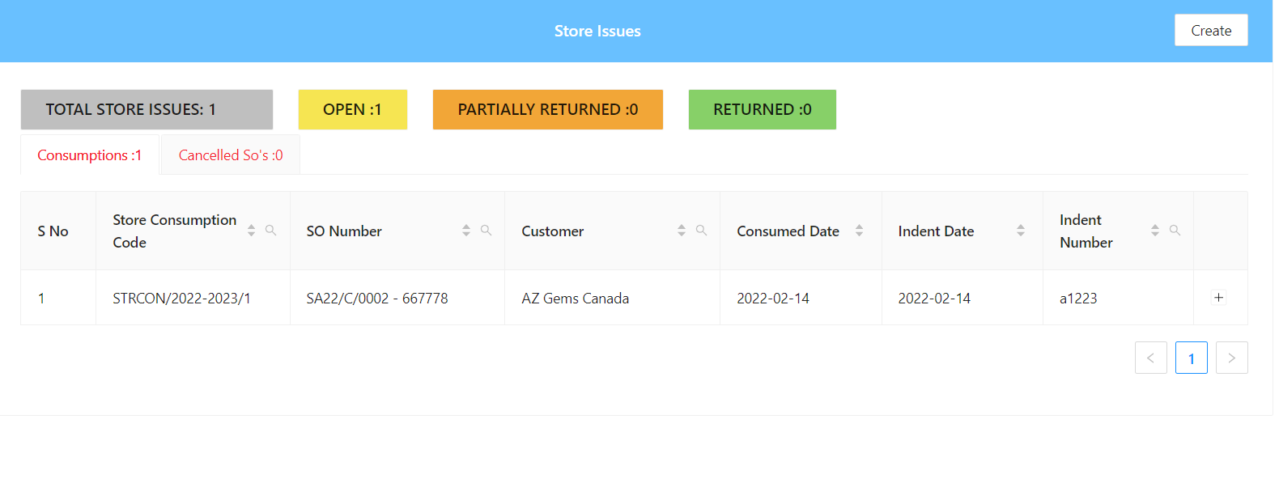

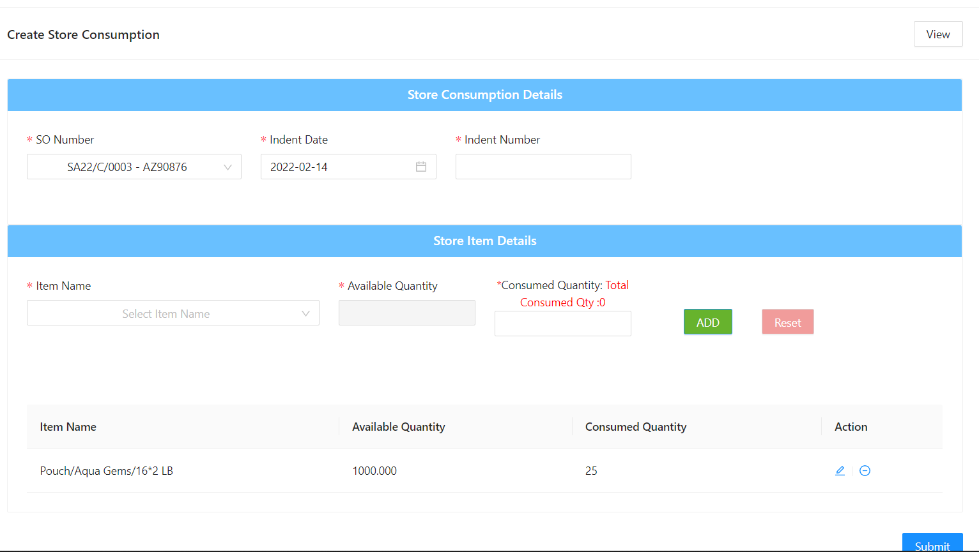

**9)Stock Return:**

* + When we have issue with the stock then we will return them then we will use this stock return.
  + When there is the stock issue then we will consume the required amount and then rest amount is shown as stock return.

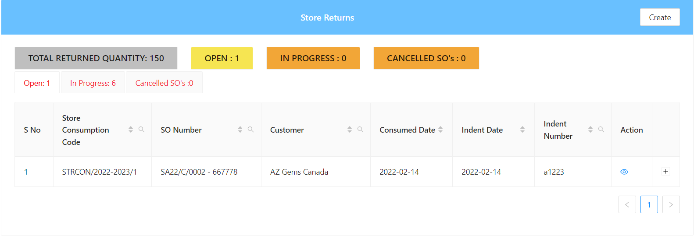

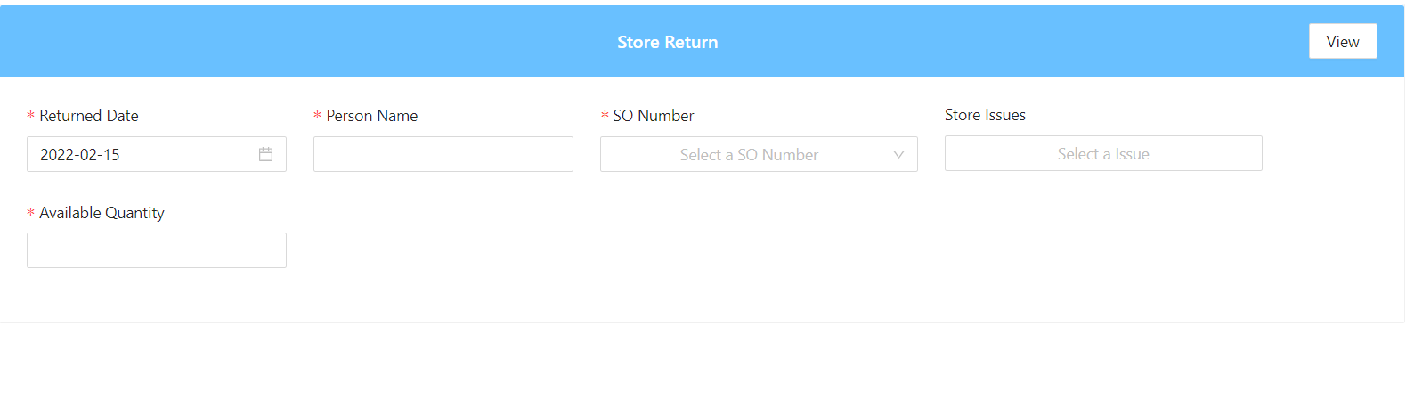

**6) Warehouse:**

**1)Stock in:**

* + - In this the stock is placed by the plant for the customers.
    - In stock type we will different types let us see of them” Anticipated, Dummy, Sale order, Super dummy”.
    - Shift are of 4 types they are “Shift A, Shift B, Shift C, General.

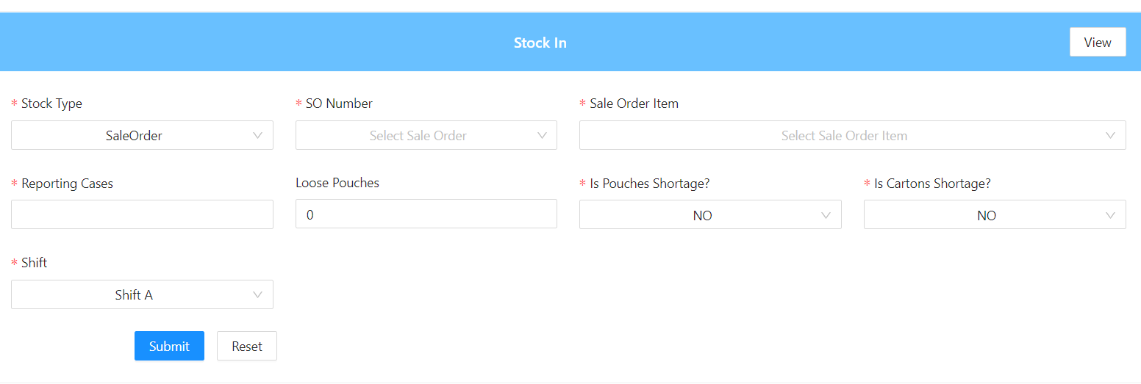

**2)Stock:**

* In this we can the grid with required details when we will place the order in the above stock in module.

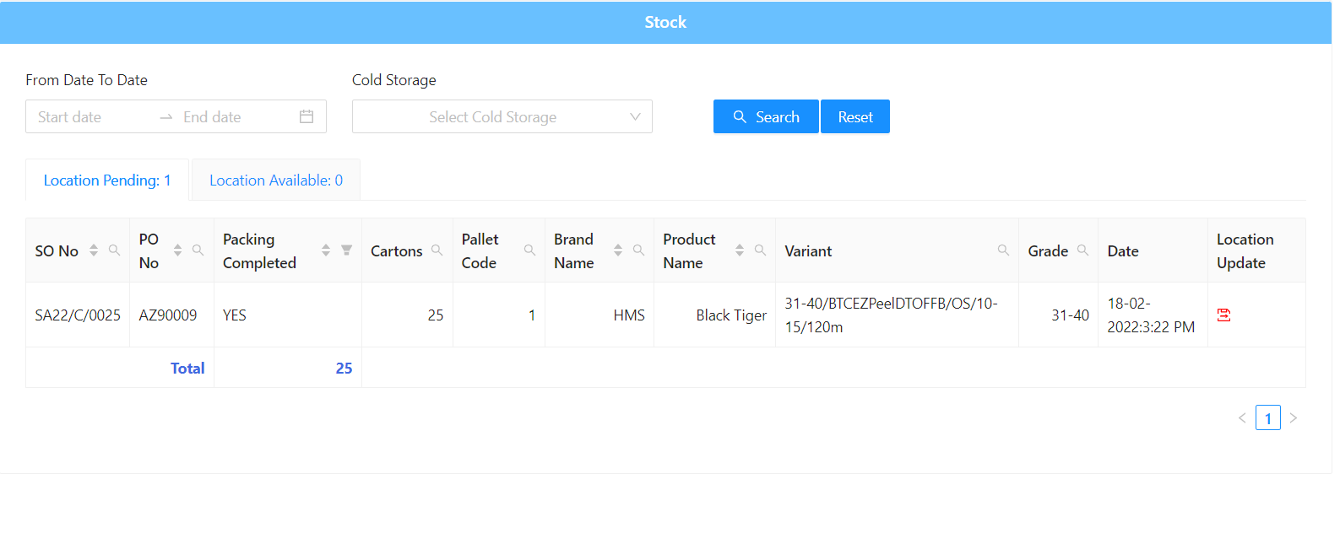

**3)Stock out:**

* + - In this we will get the order out and almost ready for placing the order on to the board.
* Even we can take the print if required by search the sale order number and take the print directly.

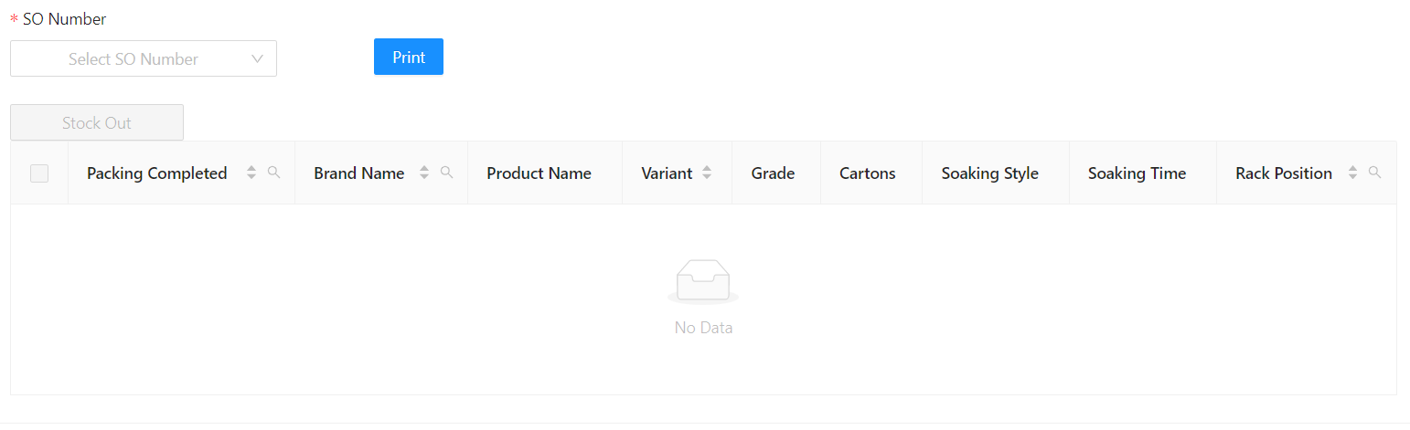

**4)Reserve Rack:**

* In this we will talk about the cold storage, and they will also talk about the racks and the where the orders need to be stored in it.
* Here will find 2 different types in the So type one is “Sale order” and the other one is “Dummy”.

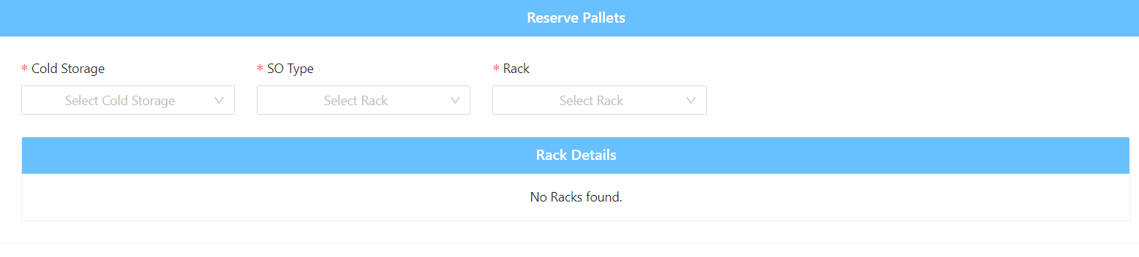

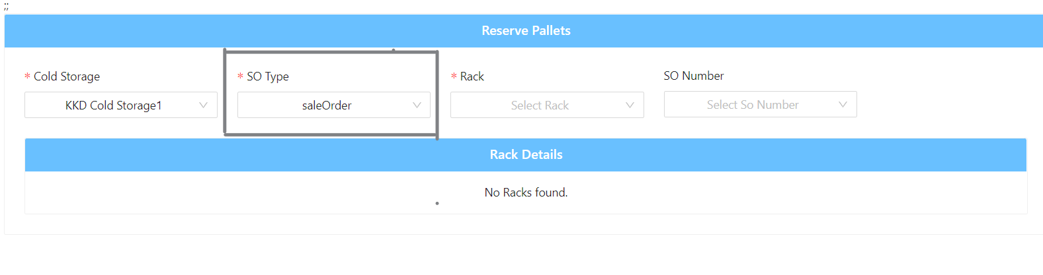

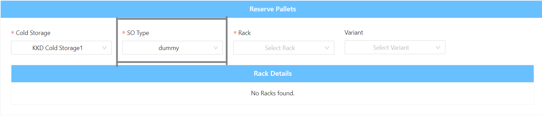

**5)Reprocess & Repacking:**

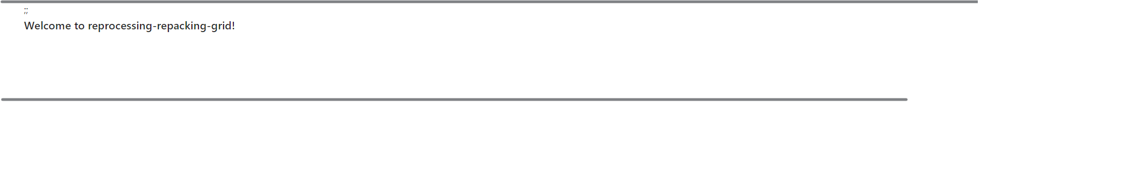

**6)FG Stock Transfer:**

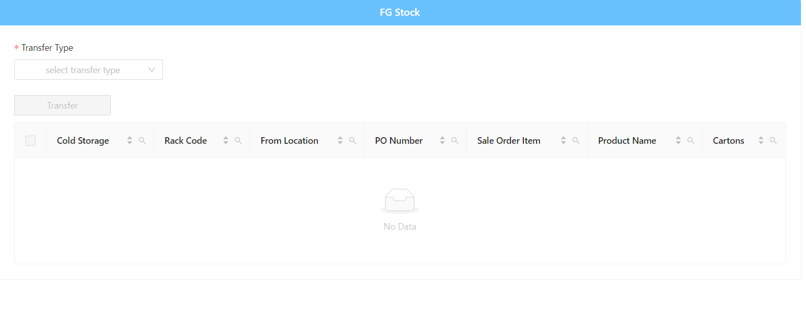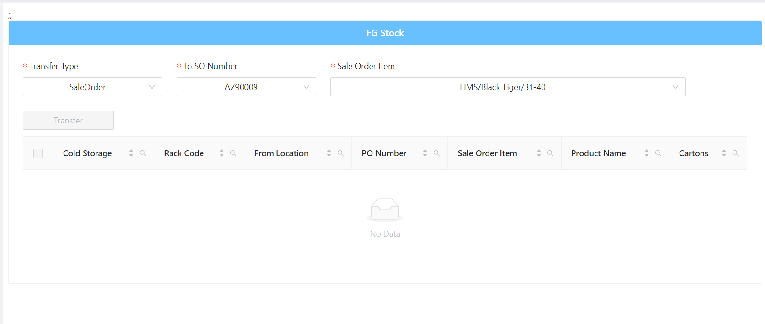

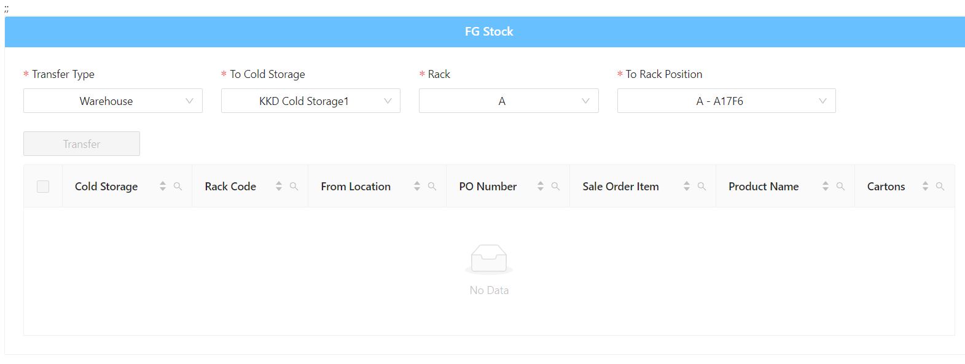

**7) Logistics:**

**1)Container Register:**

* In this when we will start for the boarding then we will start the registration of the containers.
* In this we can also book a slot for the order and we can check the gross weight of the product weather they conformed or not for the provided details.

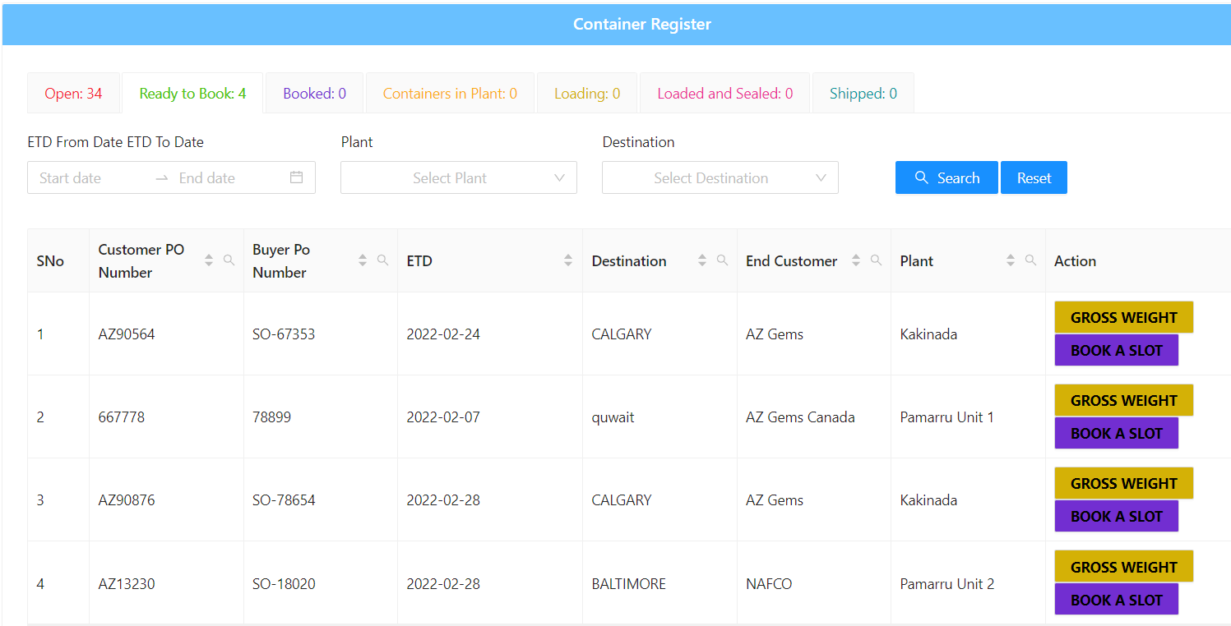

**2)Bill of Lading:**

* In this we will get bill of the product before and check weathers all the details are sufficient or not.

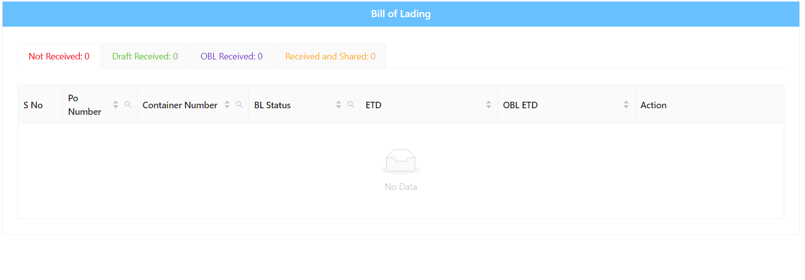

**3)Invoice:**

* + This an official paper that lists goods or services that you have received
  + Says how much you have to pay for them.
  + In this we will find important details of the product before they get transferred.

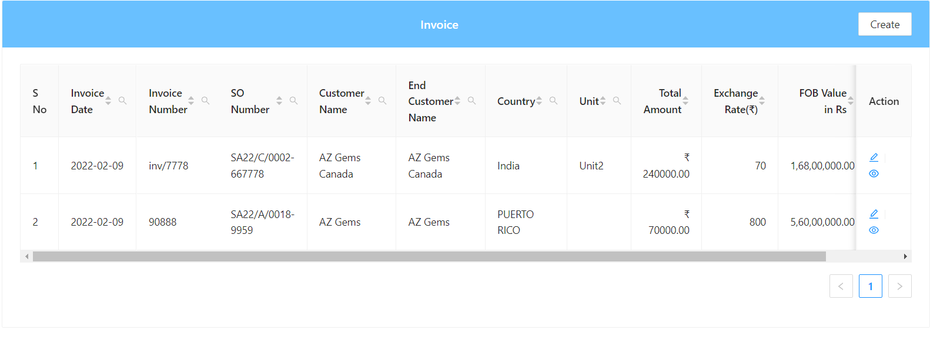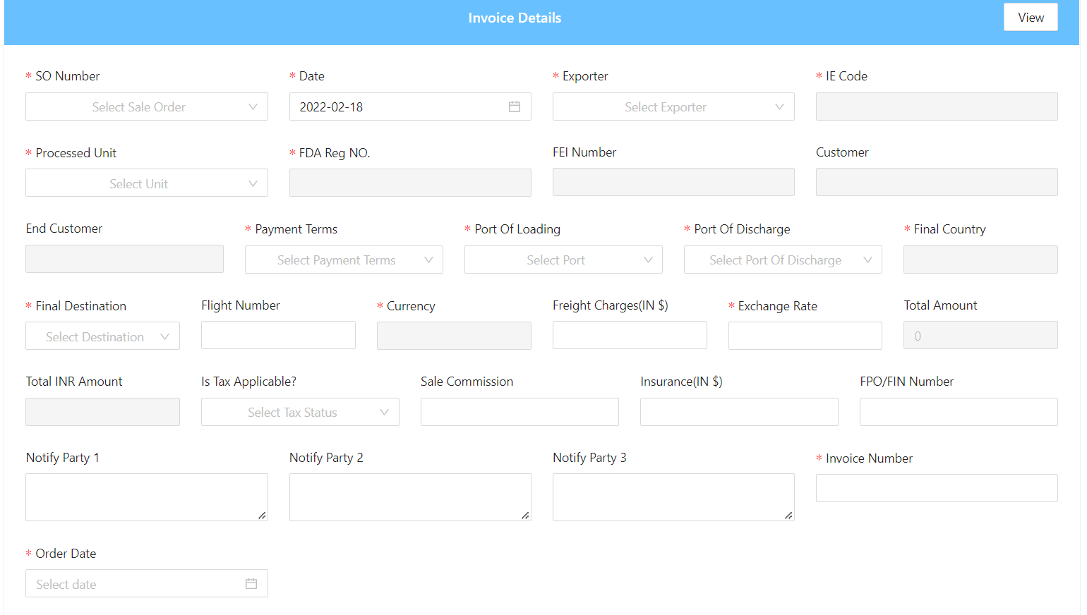

**4)Document Register:**

* Is a list which identifies all business documents and includes current revision status.
* If we fell some document is missing then we can upload.

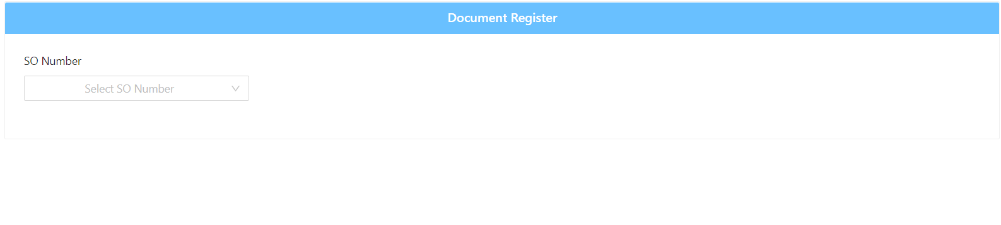

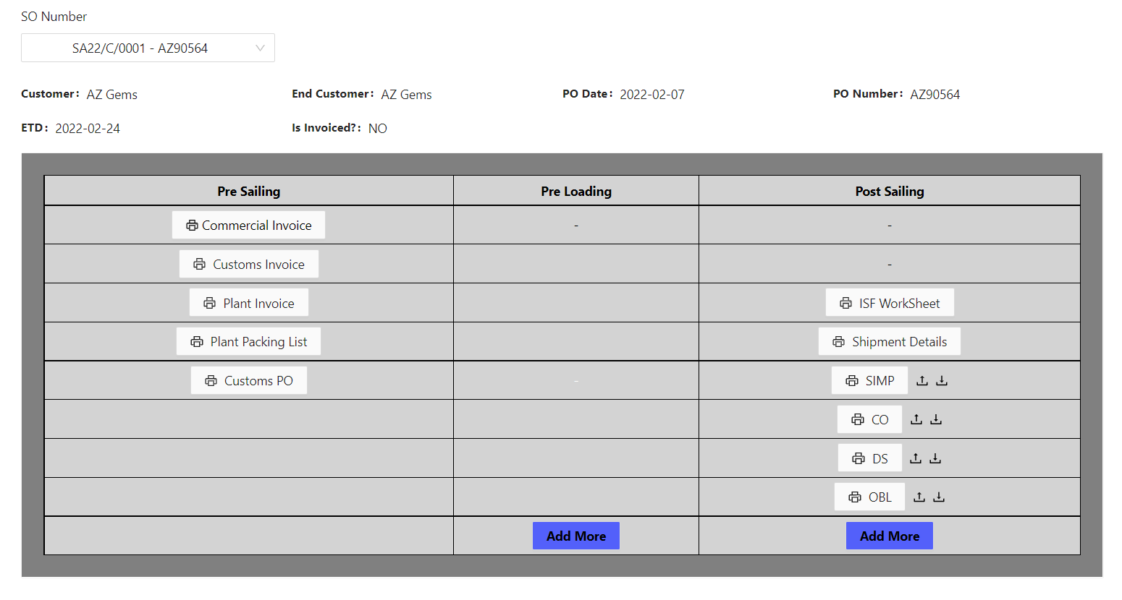

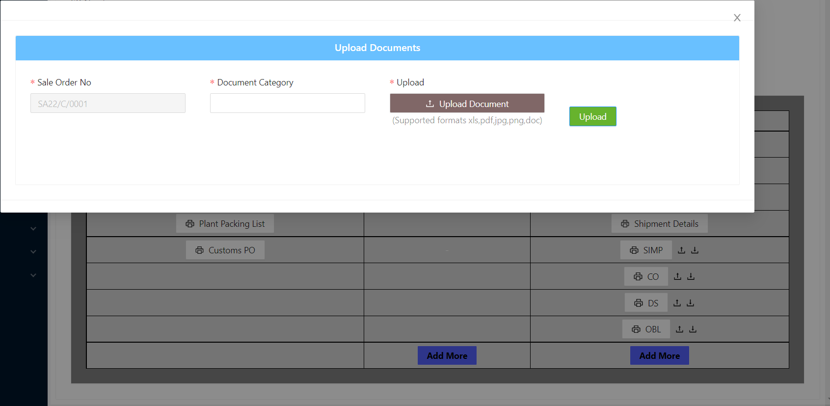

**5)Documentation Approval:**

* This is the strategic sequence of steps and tasks a team needs to complete to review and approve internal and external deliverables.

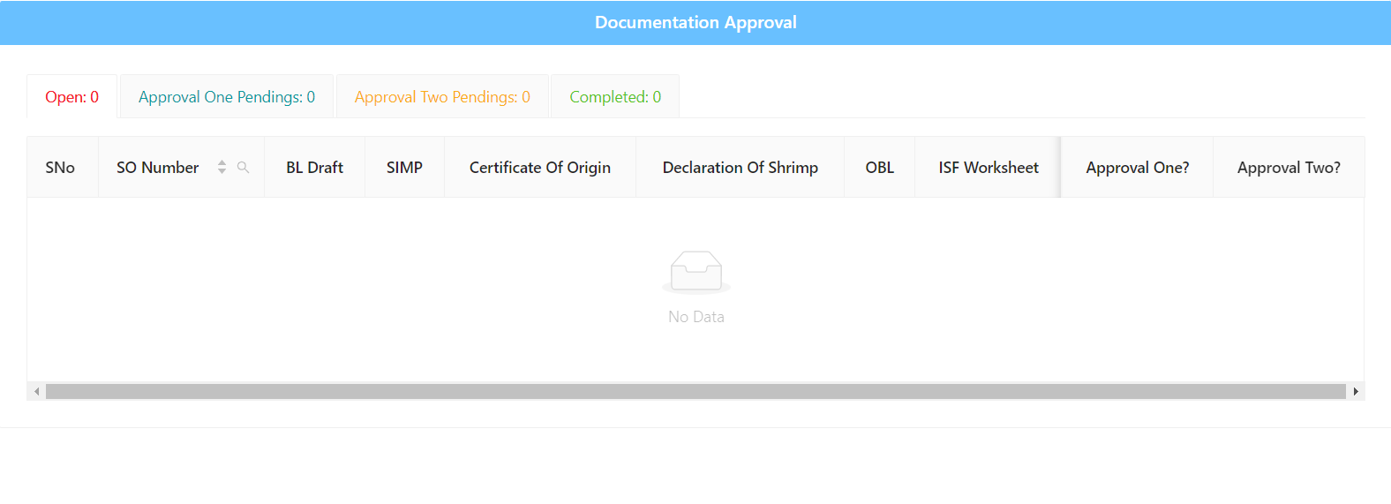

**6)Log Book:**

* This is the final step before the product go out the plant.
* Until the container is recorded the details the log book they are not supposed to go out.

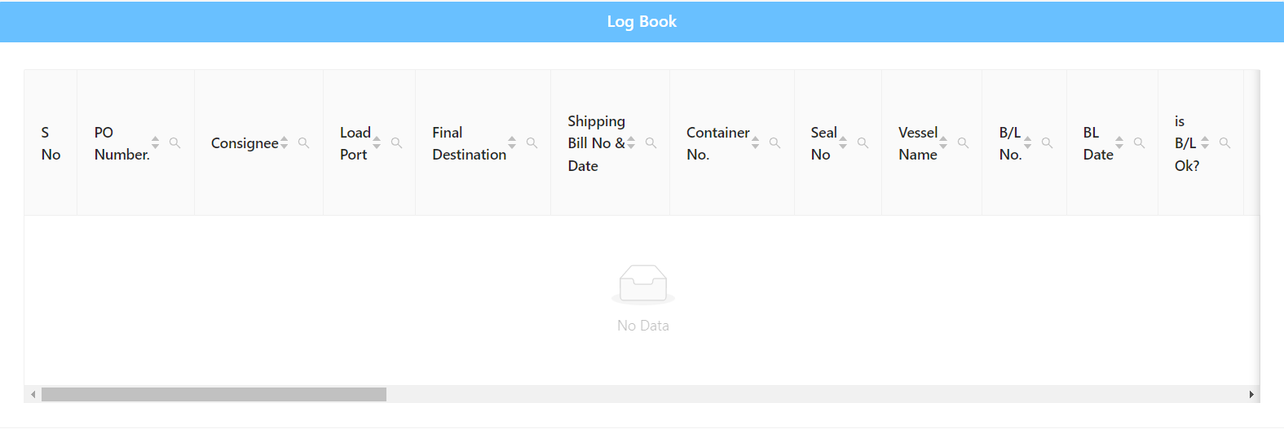

**7) RM Production:**

**1)RM Dashboard:**

**2)Procurement Dashboard:**

* + - It will contain final gist of the Rm production module.
    - The details this dash contain is of the materials to be produced, indent, farmer, Pending GRN quantity.
    - The bar graph for count range weight in tons.

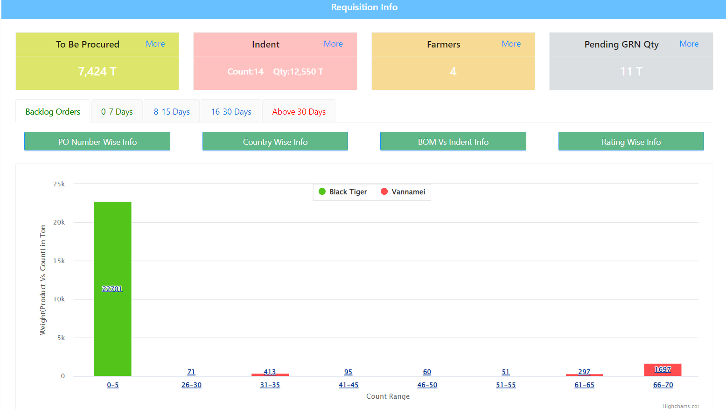

**3)Indent:**

A company document used internally in the purchasing process to authorize the requisition of materials prior to initiating a purchase order. 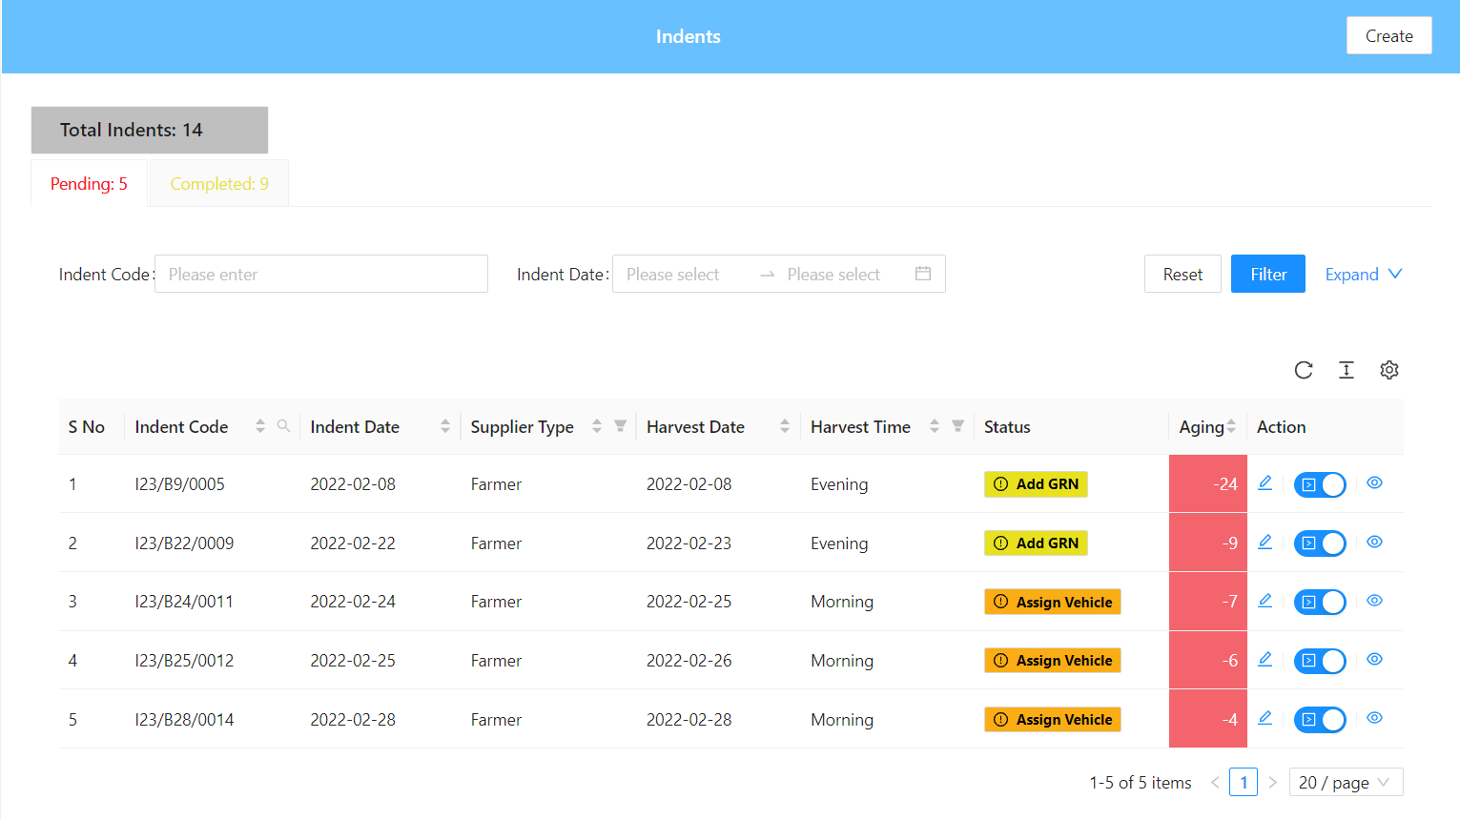

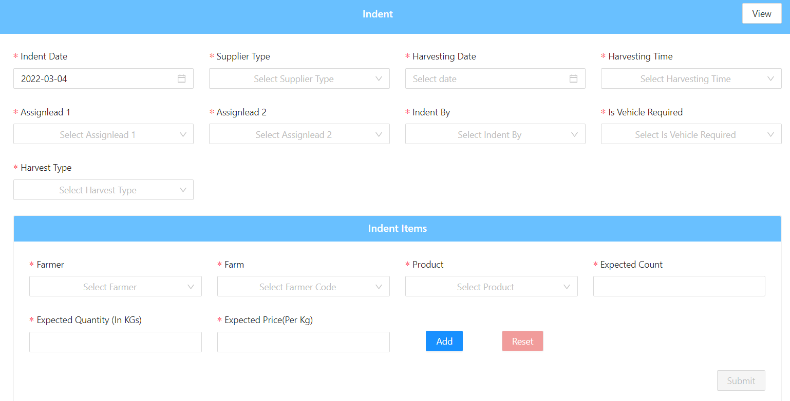

**4)Assign Vehicle:**

Here we will see whether the product is assigned with the vehicle or not .If not we can assign the vehicle for it. 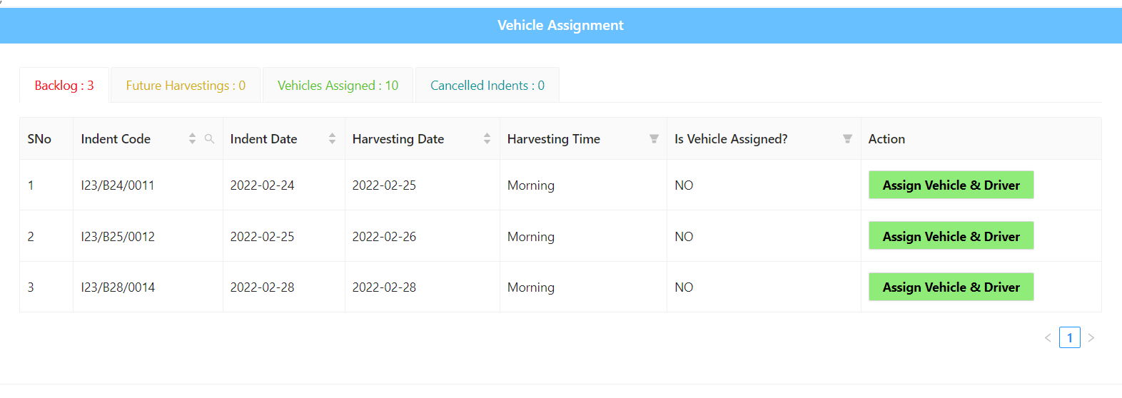

**5)GRN:**

Goods Received Note is a record of goods received from suppliers, and the record is shown as a proof that ordered products had been received. Moreover, the record is used by the buyer for comparing the number of goods ordered to the ones delivered.

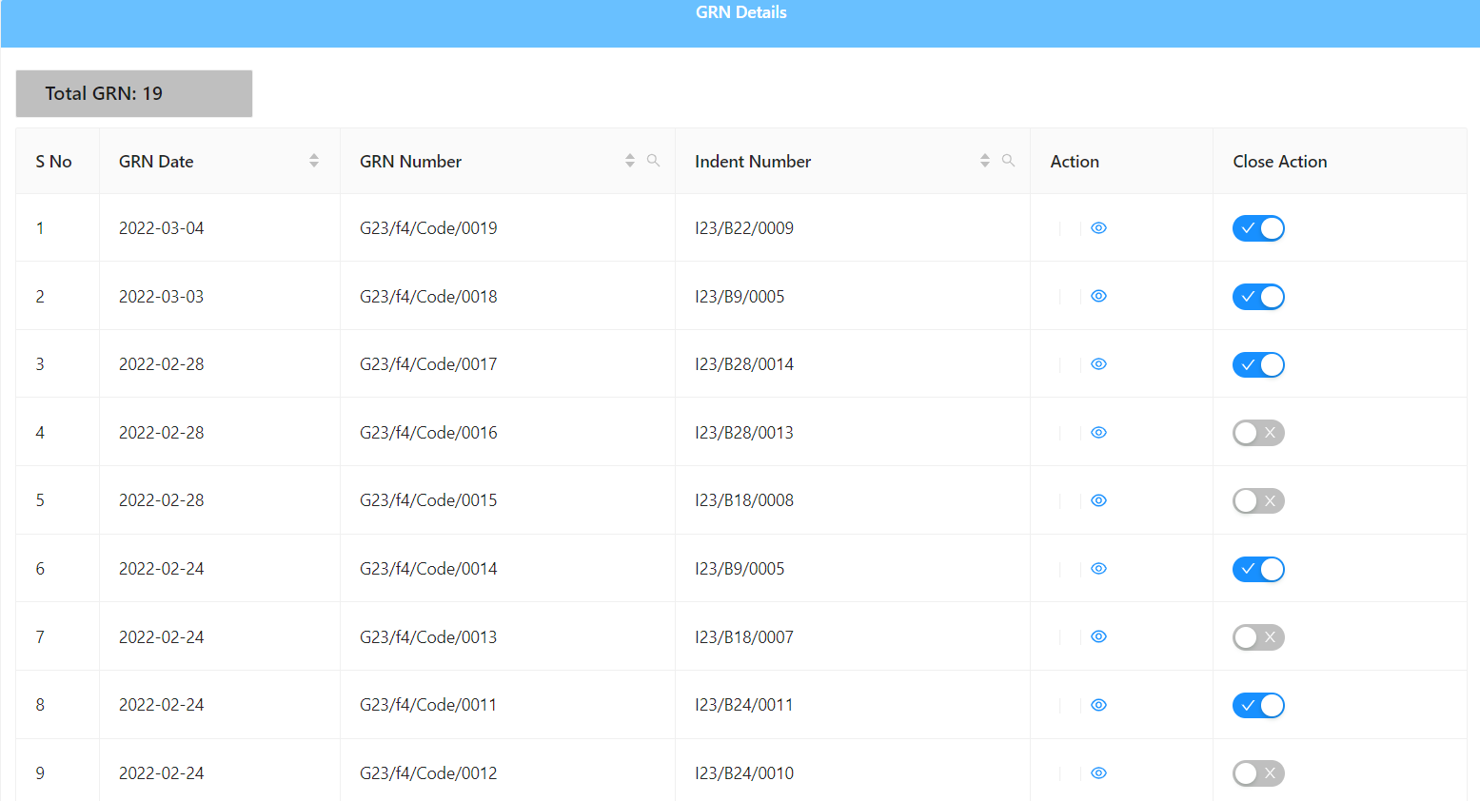

**6)BOM Tracker:**

Bill of materials (BOM) software automates the process of listing the individual components that make up a product in the manufacturing setting. Users can create item profiles for every part that goes into a specific product, then use these to create multiple lists for a single product to show subassemblies. 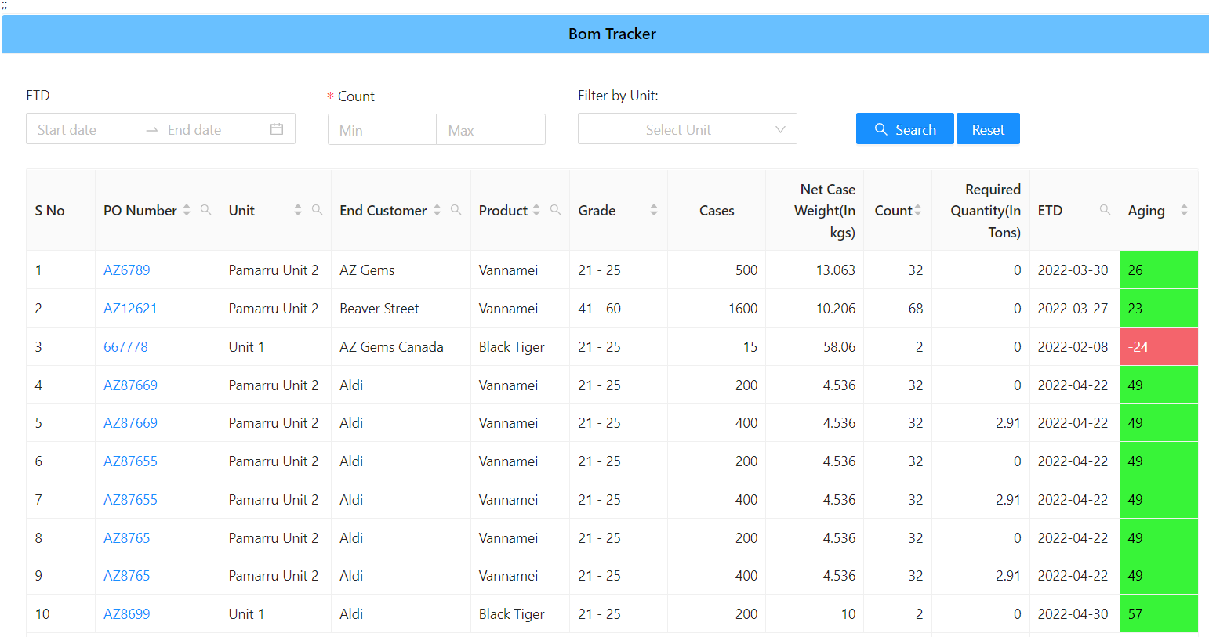

**7)RM Indent Quantity Limit:**

It will contain the measurement of indent quantity in tons and planned quantity in tons 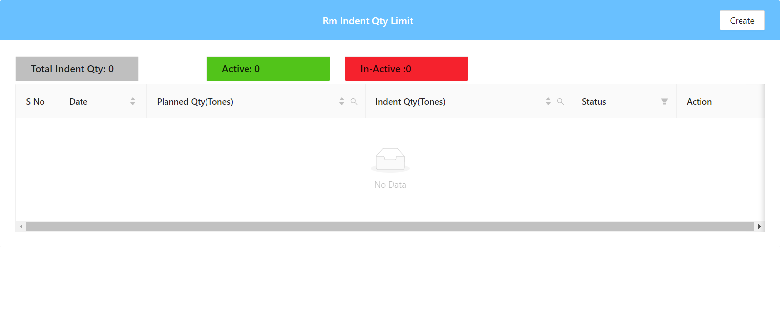

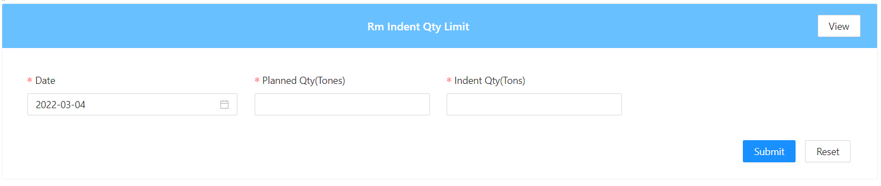

**8) Production:**

**1)RM Inventory:**

* + - Raw materials inventory is the total cost of all component parts currently in stock that have not yet been used in work-in-process or finished goods production.
* There are two subcategories of raw materials, which are: Direct materials.
* These are materials incorporated into the final product.

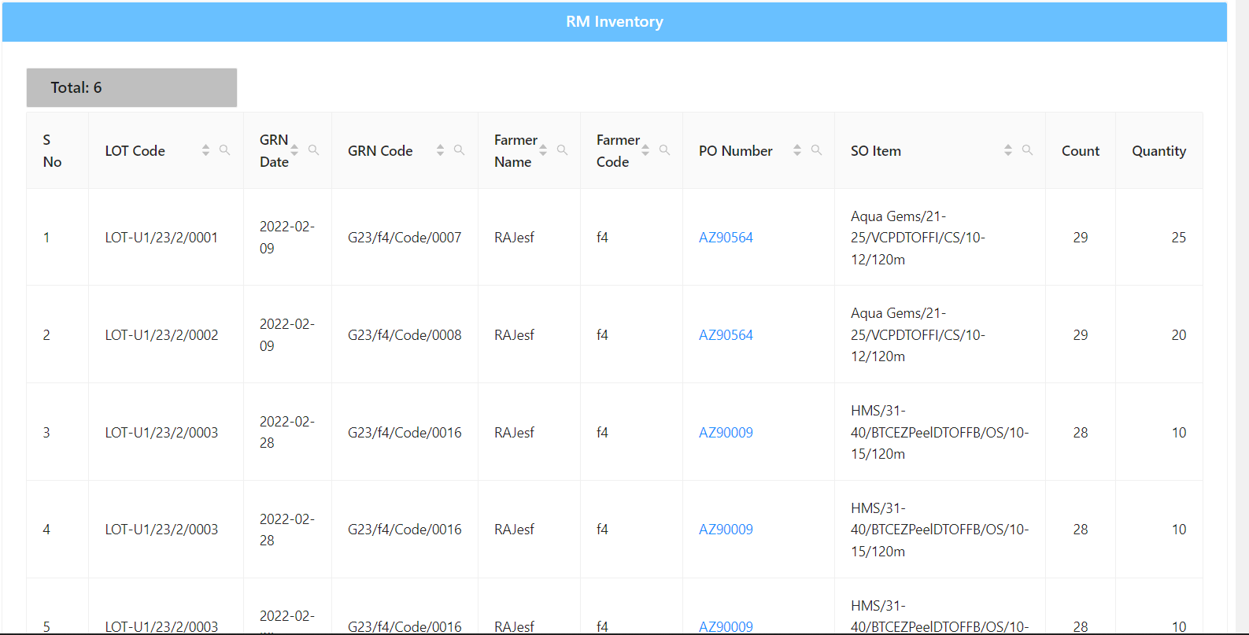

**2)Stock Transfer:**

**Send:**

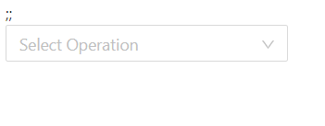

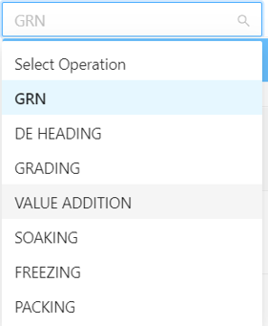

Here in which module we are sending the product to another module.

**Operation:**

Here we will see the operation which are taken place in the process.

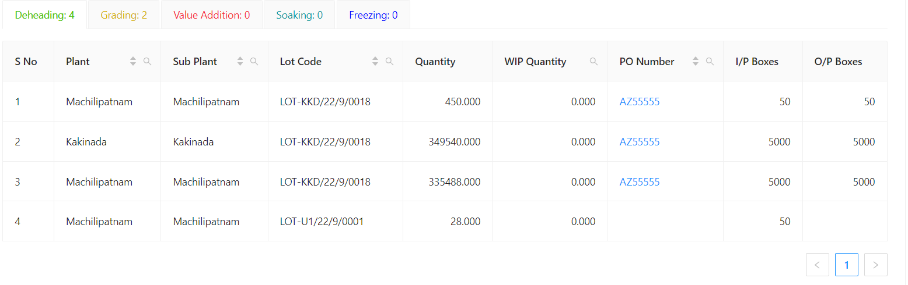

**Receiving:** 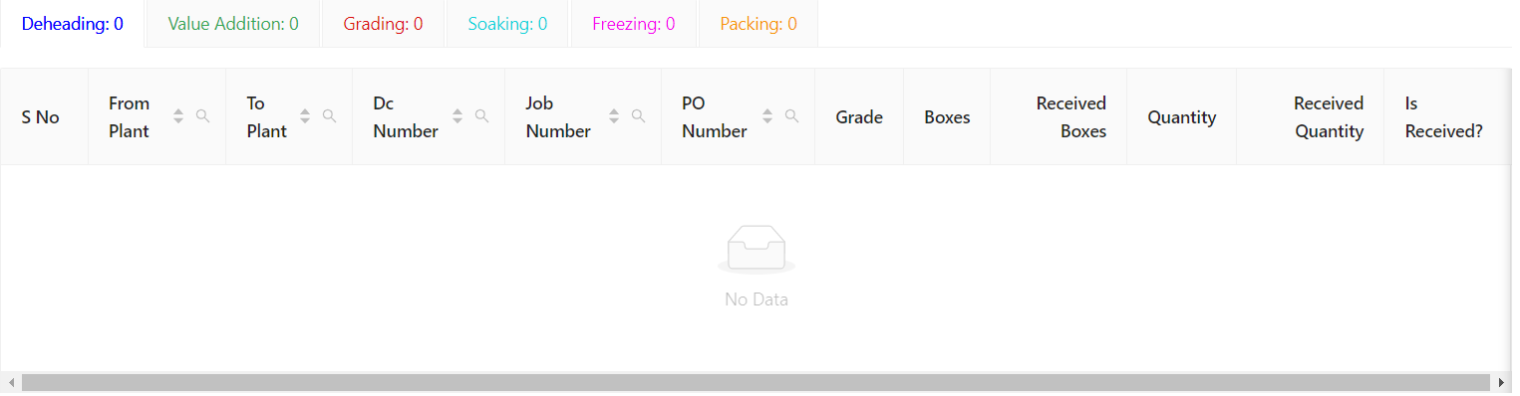

**3)De heading**

**Dehading:**

Here we will see the full details of de heading. 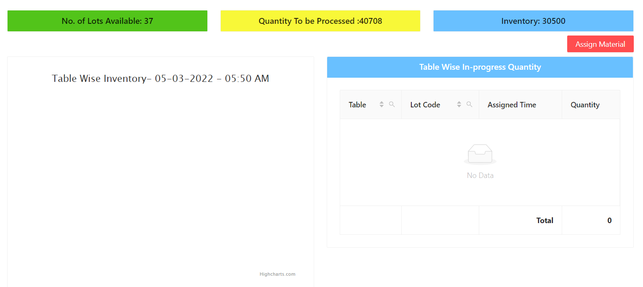

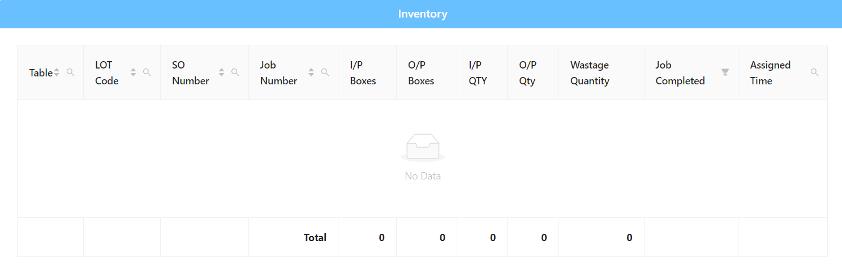

**Working progress:**

Here we will see the work progress of the de-heading in detail.

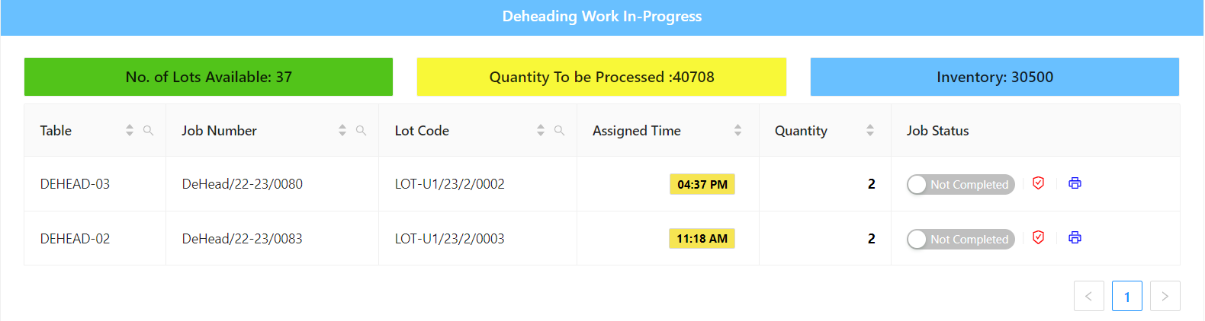

**Inventory:**

Here we will find the semi-finished goods in this process.

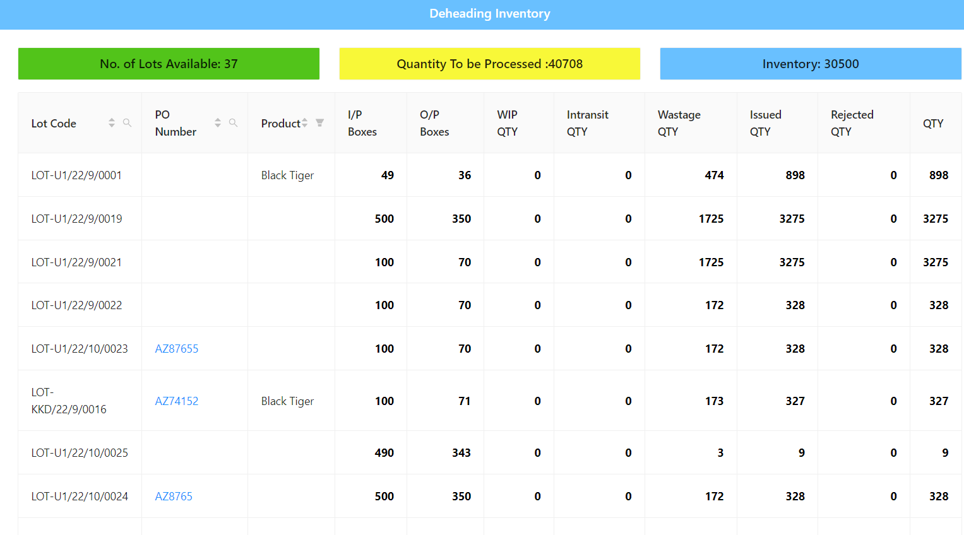

**4)Grading**

**Grading Dashboard**

Here we will the grading details in detail and many are available and how many are required and how many are not. 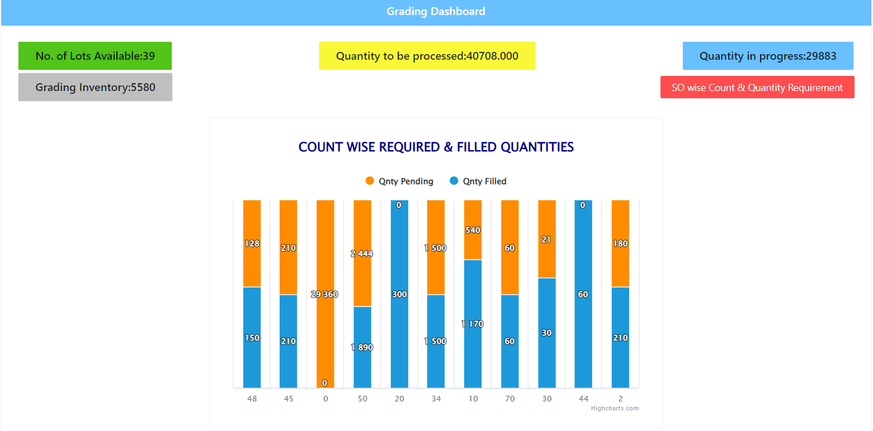

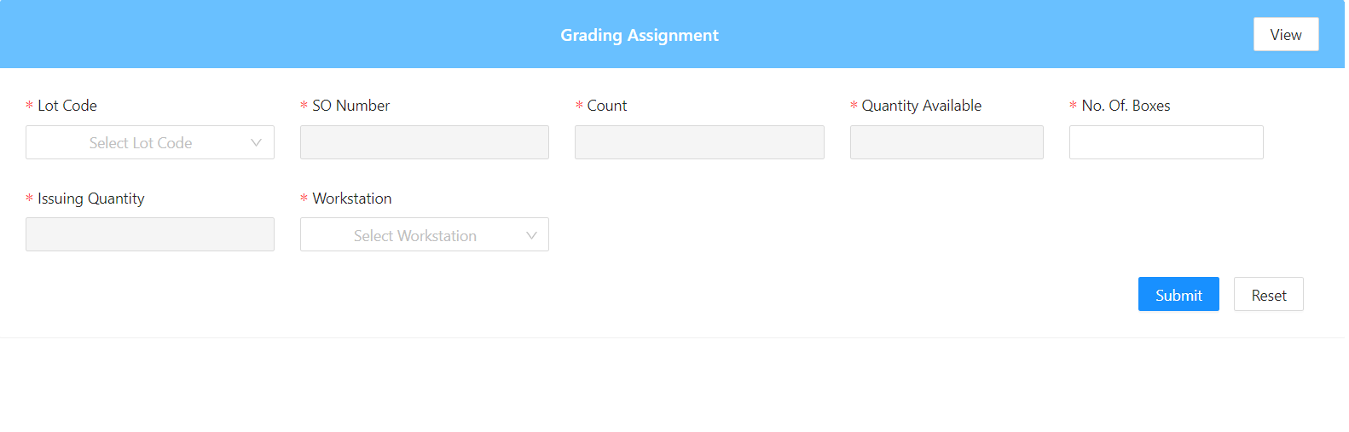

**Grading inventory:**

Here we will see the lot code and sub lot code in details and other thing in detail. We can find the product in head count and no of the boxes.

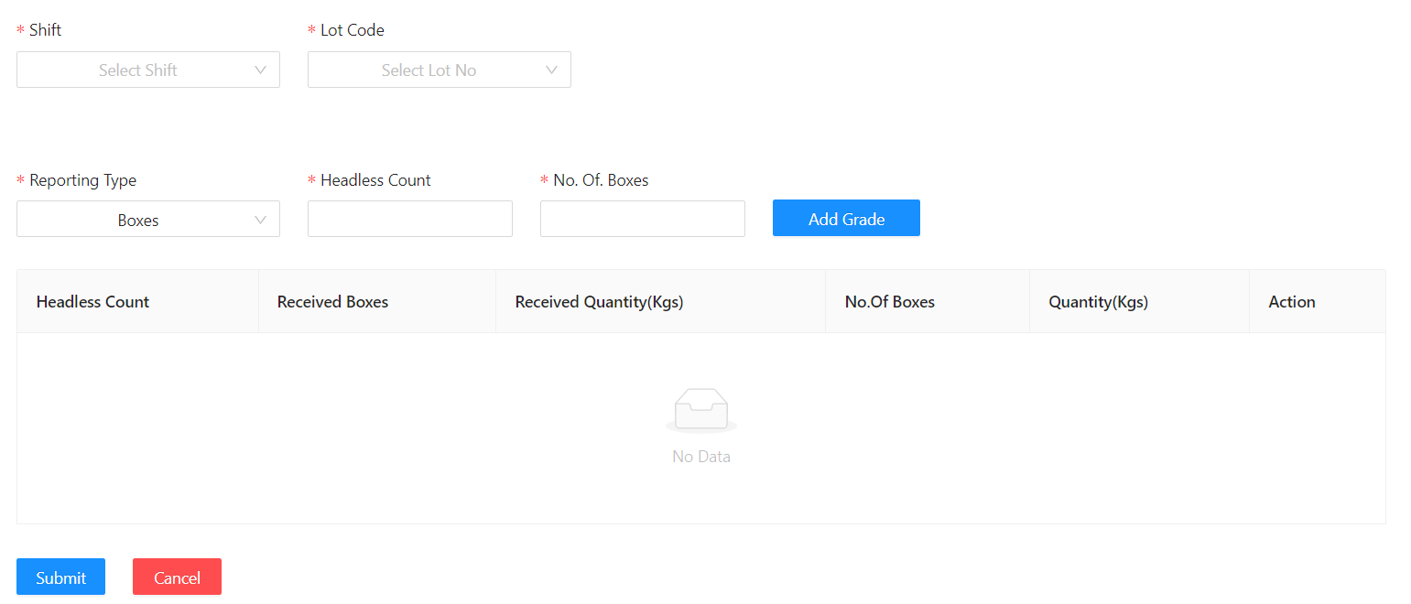

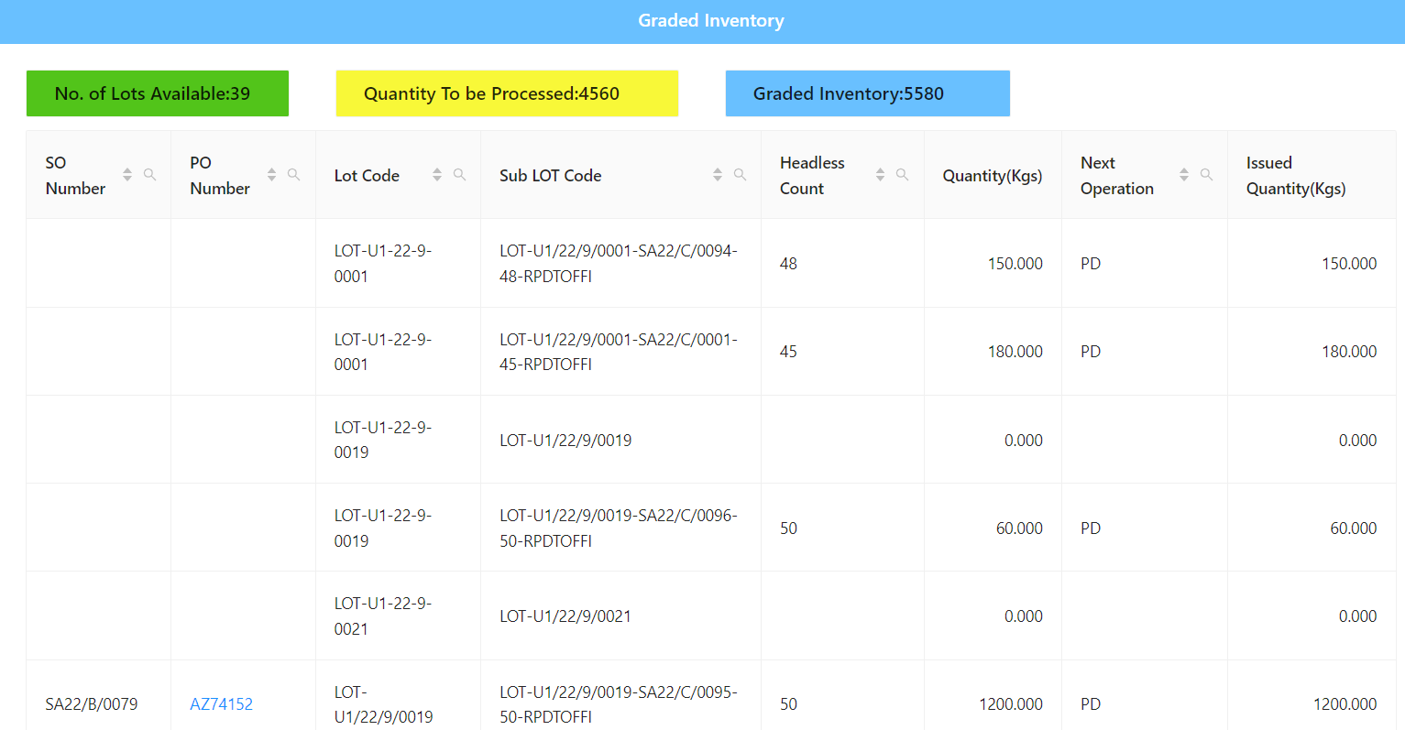

**Assign So:**

Here we will find the planned So and the Assigned So here and also find the no of headless count found here.

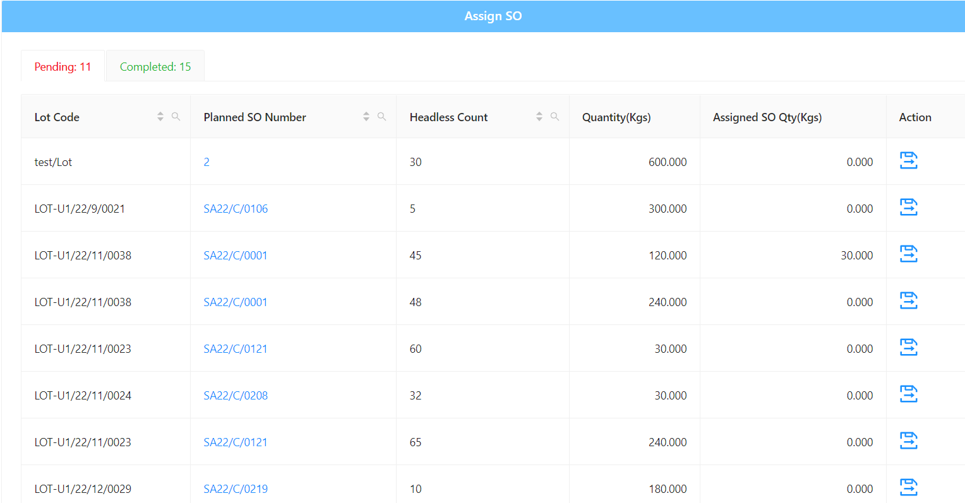

**Grading Inventory:**

Here we will find the full details of the product in the grading module.

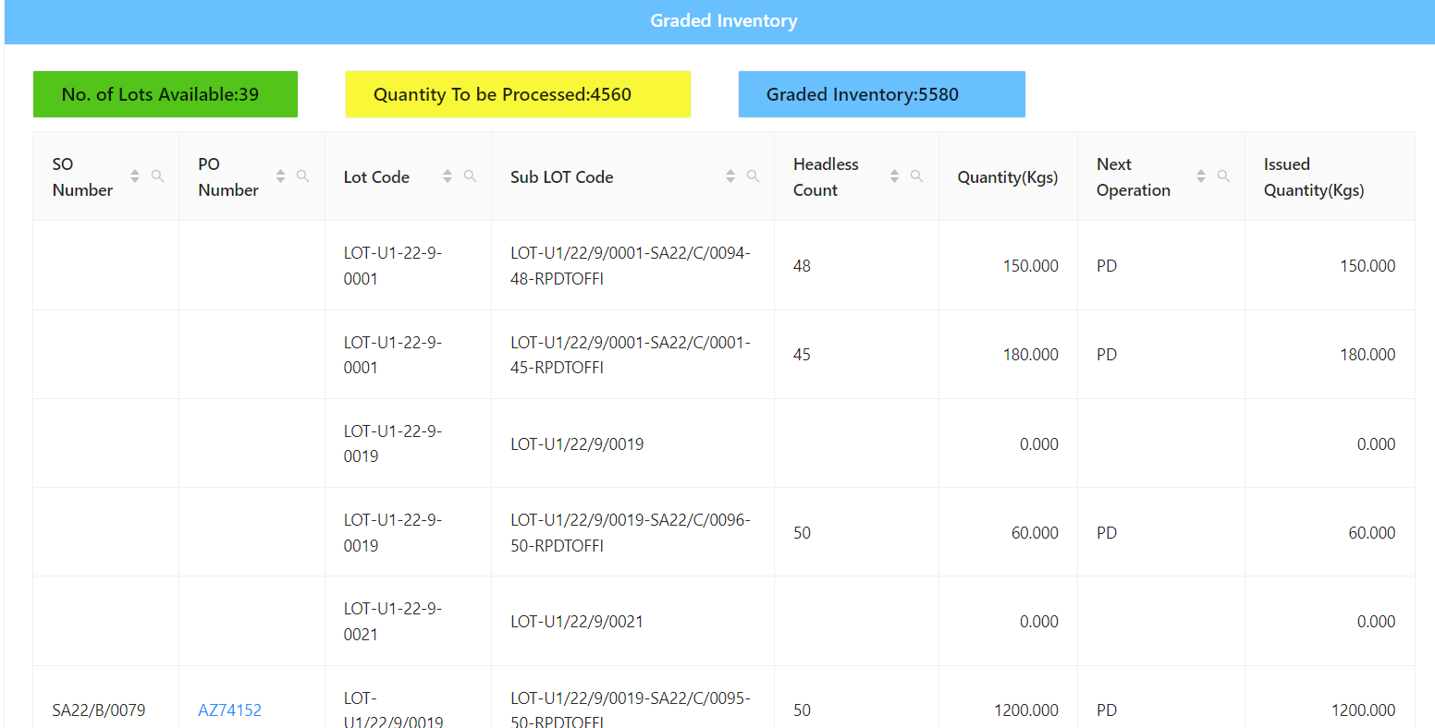

**Yield Report:**

Here we will find the Report of the suppliers, farmers, and others details with are needed in the yield.

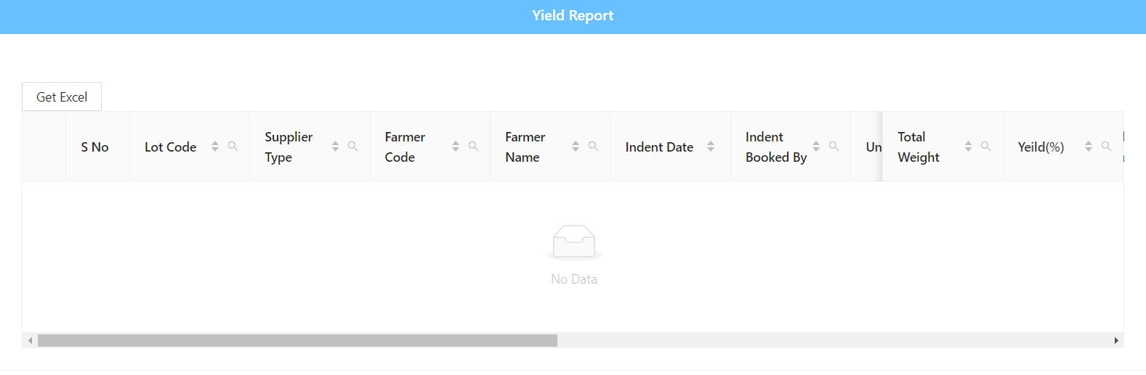

**5)Value Addition**

Here we will find the lot availability, quality processed and the graded inventory. 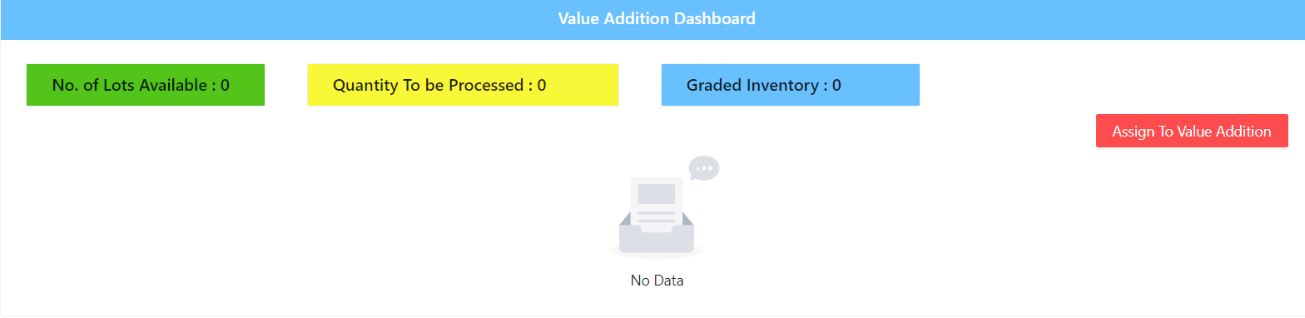

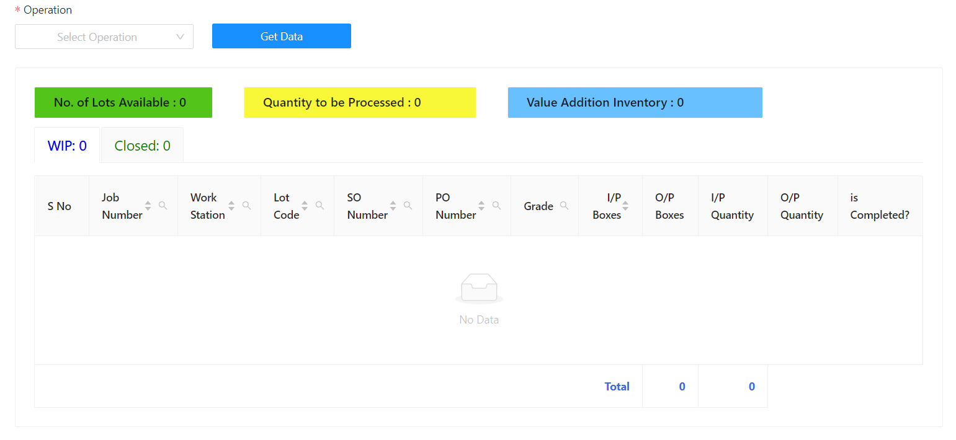

**6)Soaking**

Here we will find the what are the types of socking process are there are selected for each sale order. 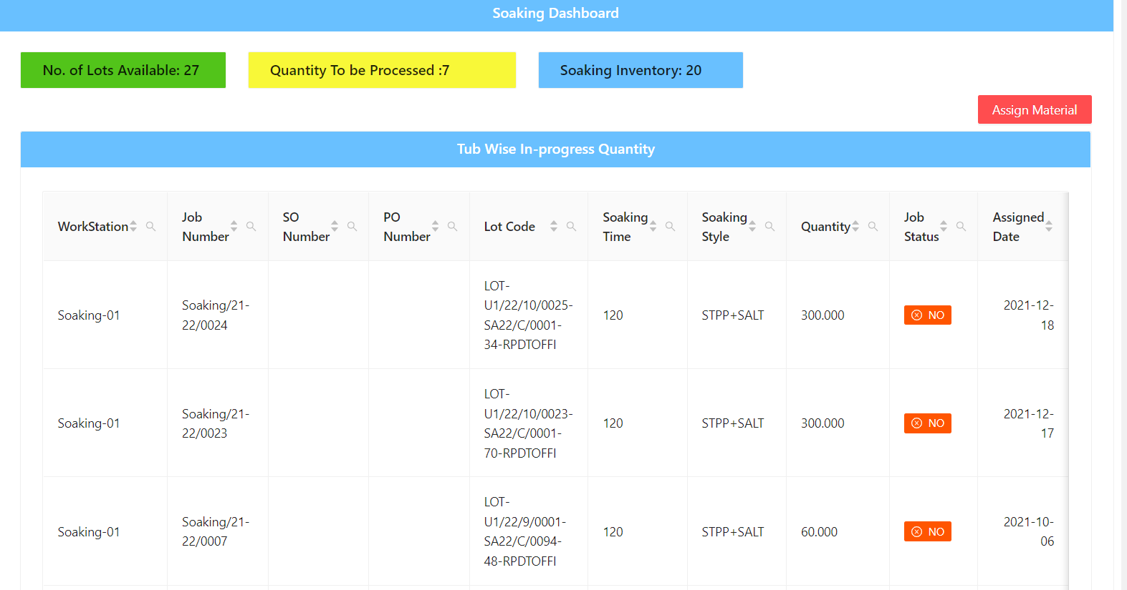

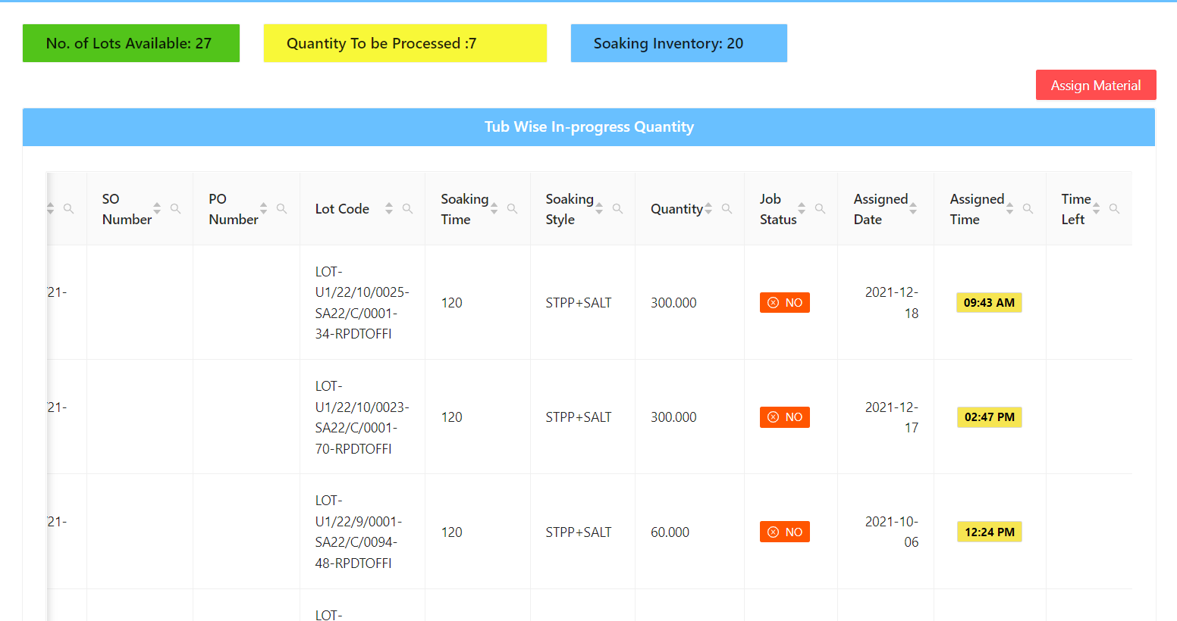

**Value Addition Inventory:**

Here we will find the product is having the socking process or not, if not we will recheck weather we have given them the correct details or not ,if any mistake happened then they will change it.

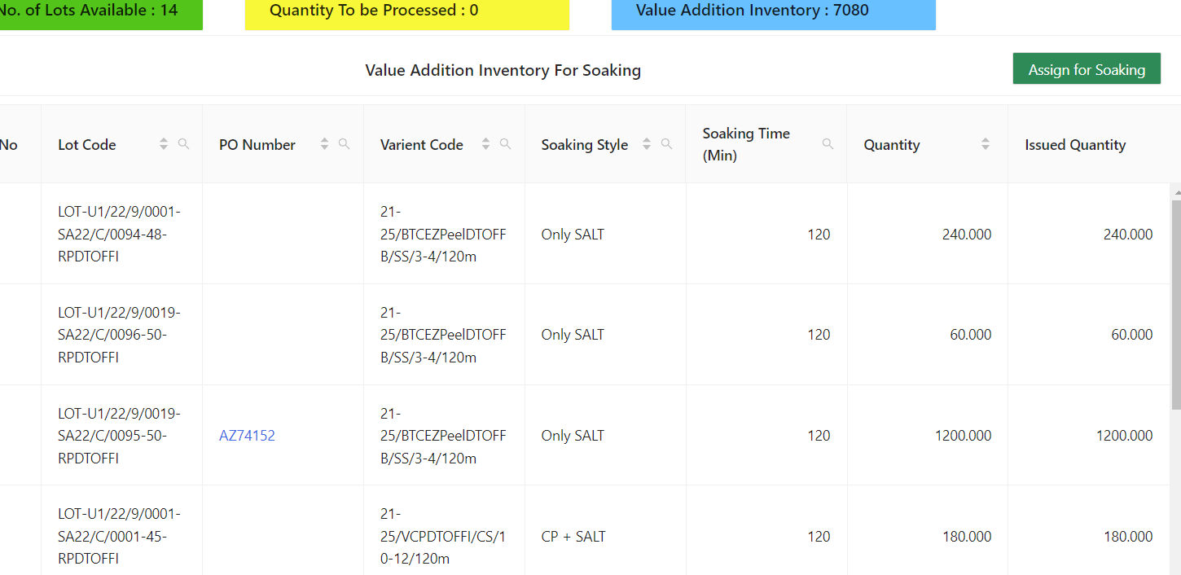

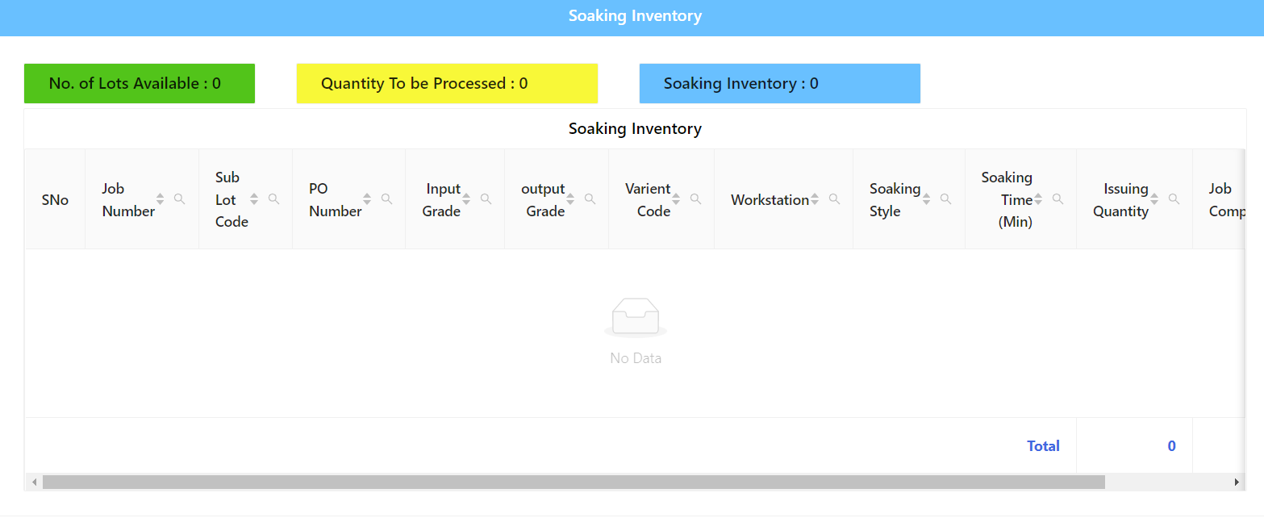

**7)Cooking**

If the client need the product to be cooked then will cook the food, to track the product then they will find it using lot code

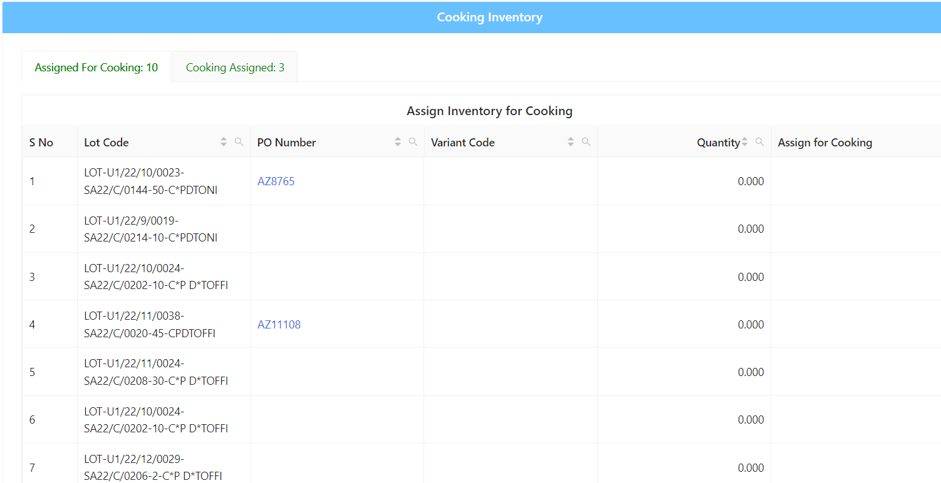

**8)Freezing**

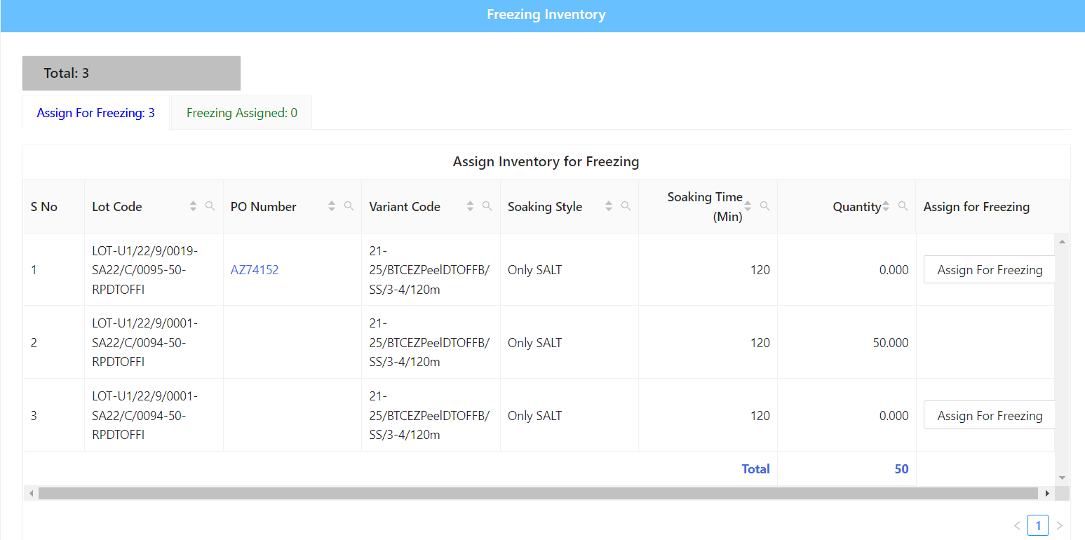

**9)Rejection**

If any problem with the product then they will reject the product and they will resend the back again

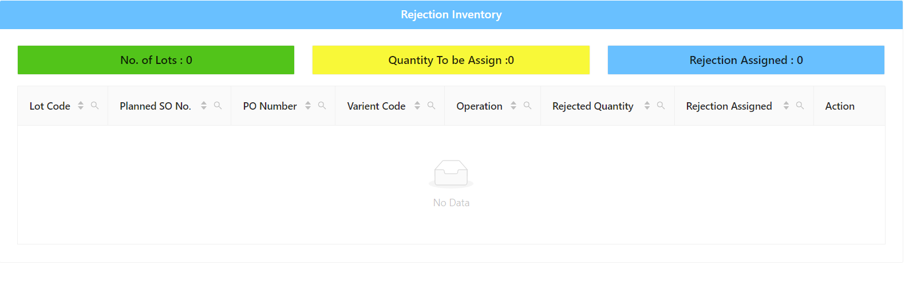

**9) QA/QC:**

**1)QA/QC:**

Here we will check the quality of the analyze the product.

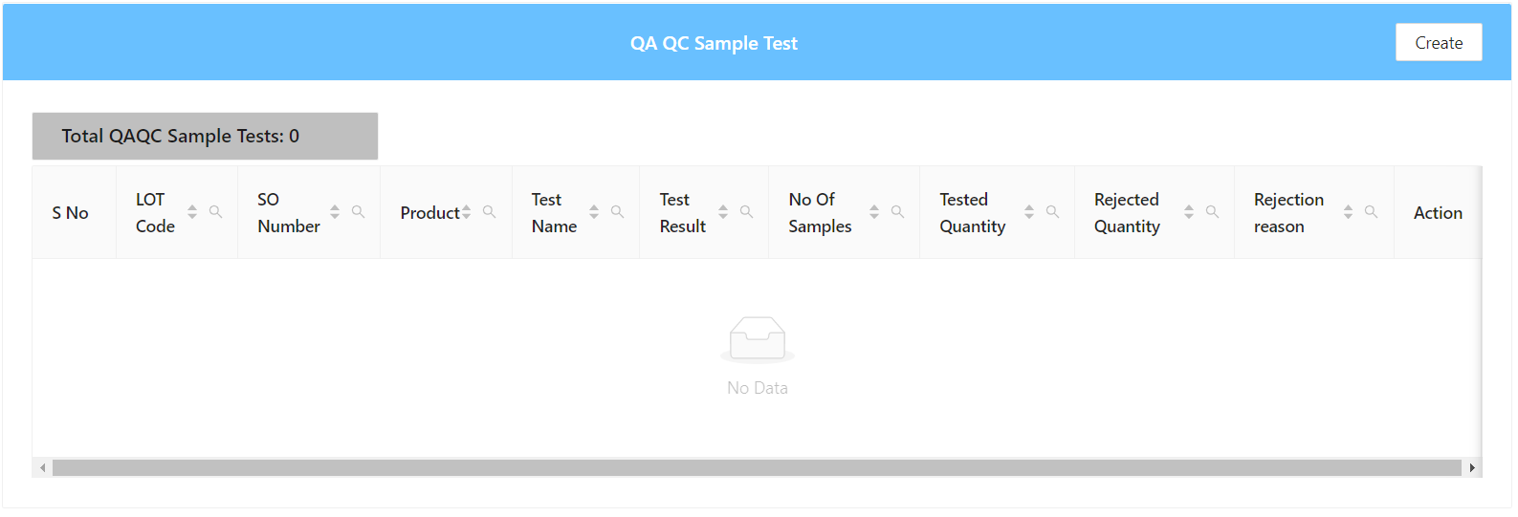

**2)Labelling:**

After the quality check is completed then they will label it that it done

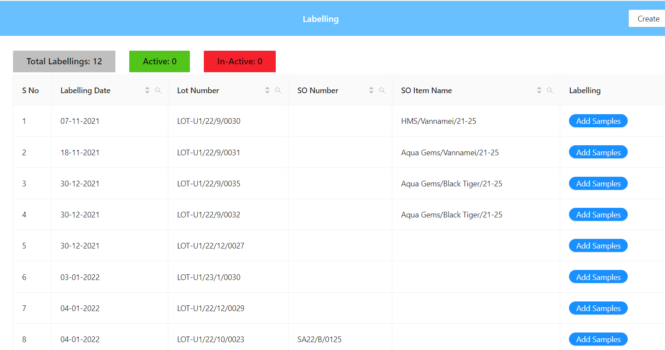

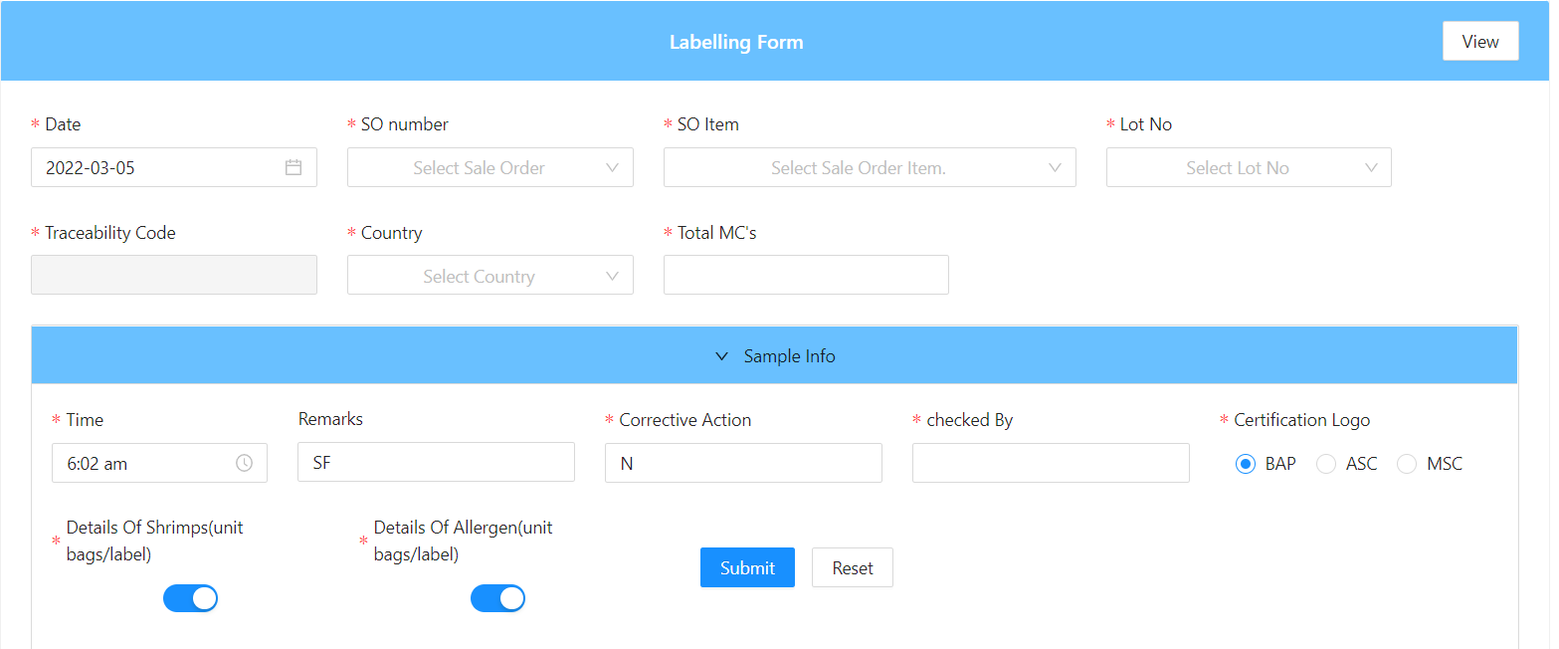

**3)FG Inspection**

This is one kind of inspection for the product to check whether the product is perfect or not 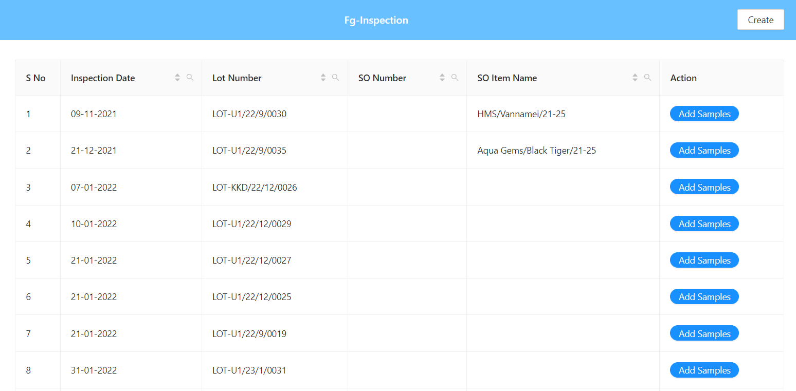

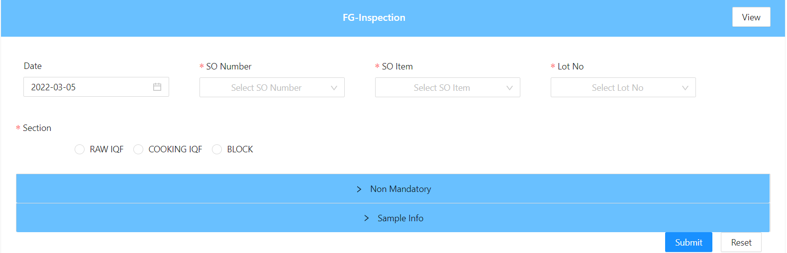

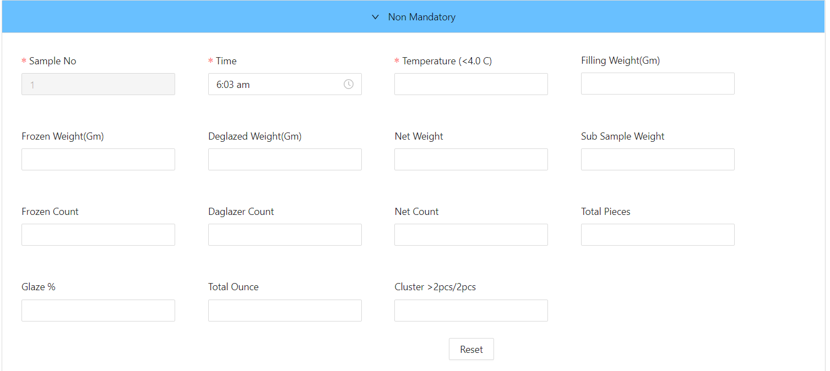

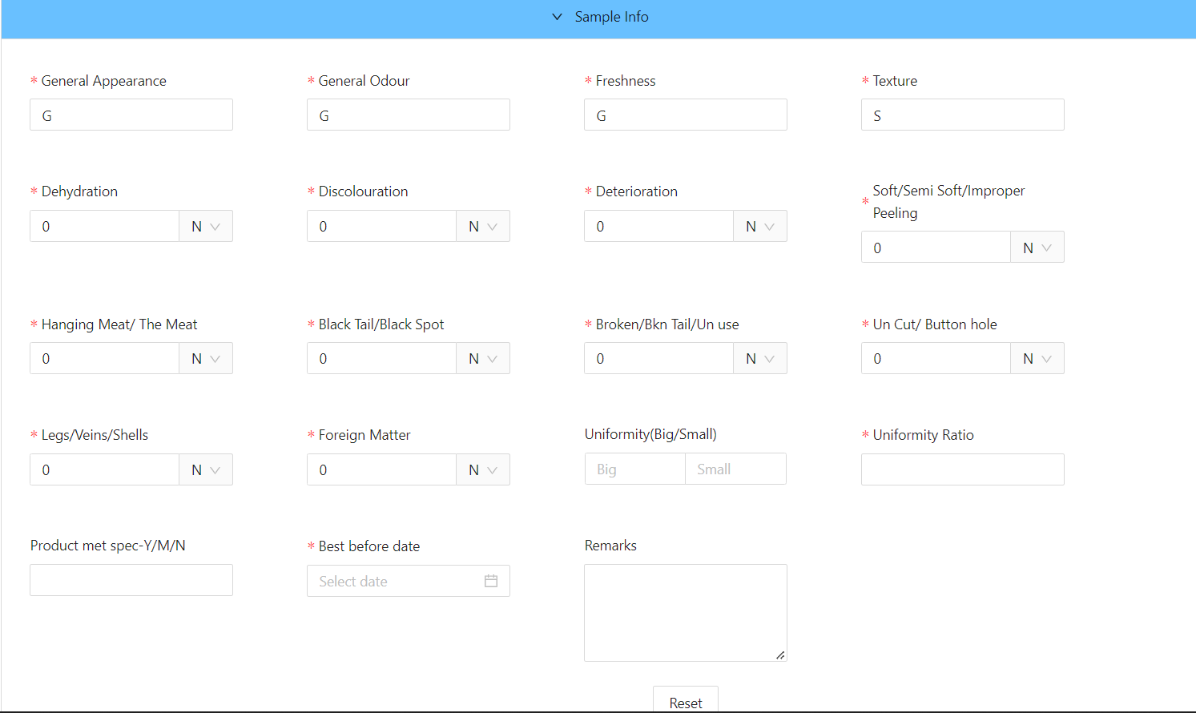

**4)Product Inspection**

It is the inspection to check the product is which is sent to the client is perfect or not.

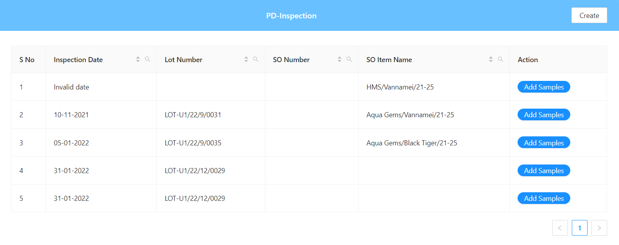

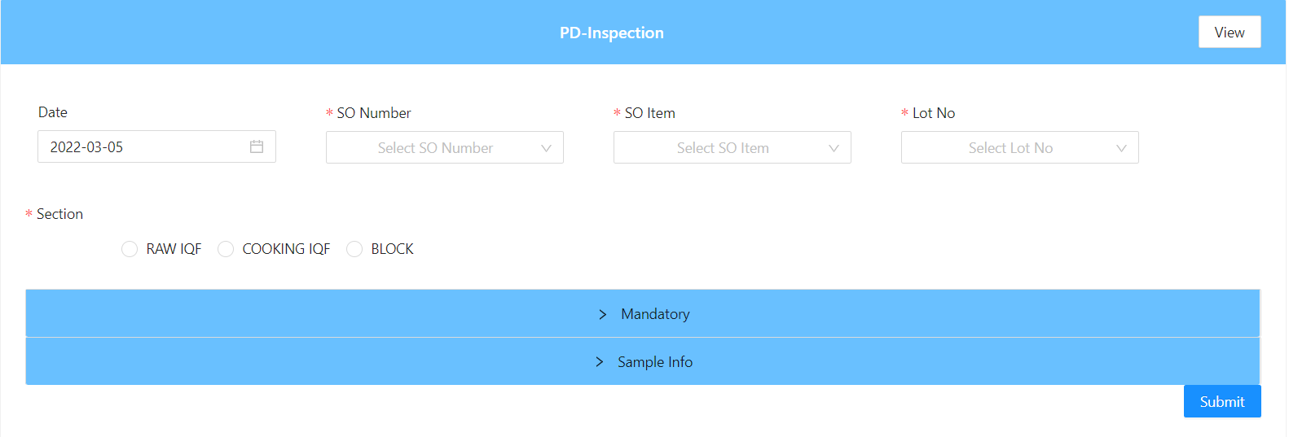

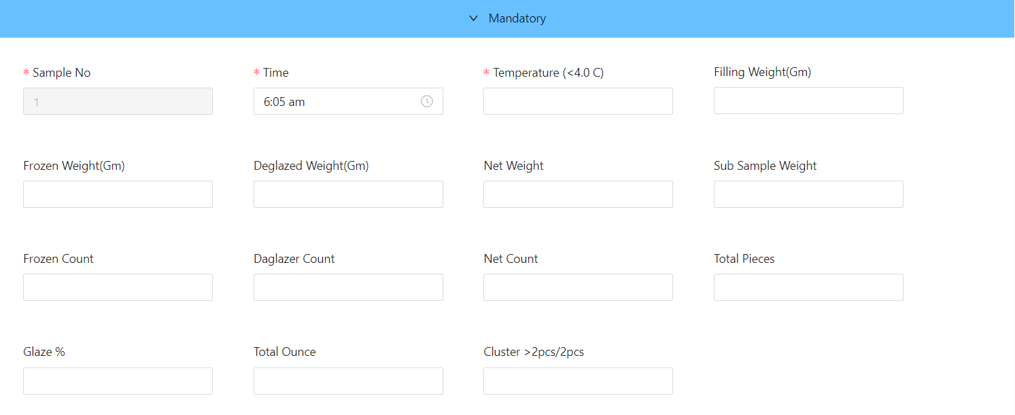

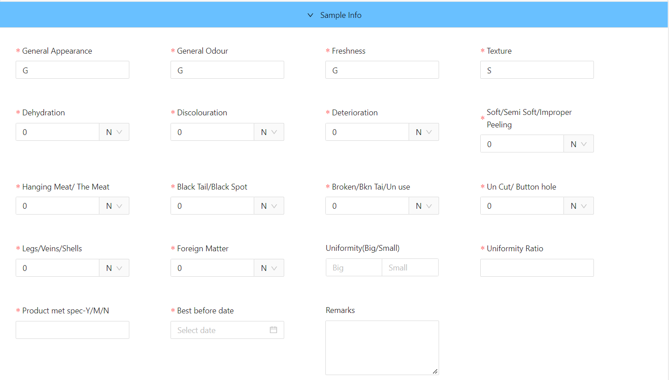

**5)PD**

In this we will lot number, so number, So item name in detail of the product. 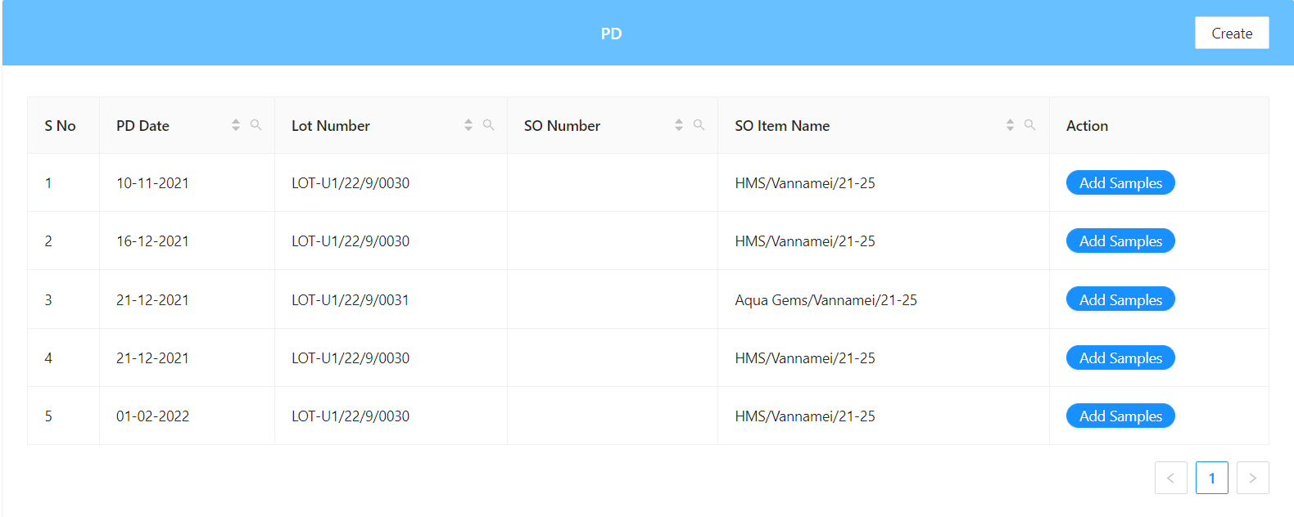

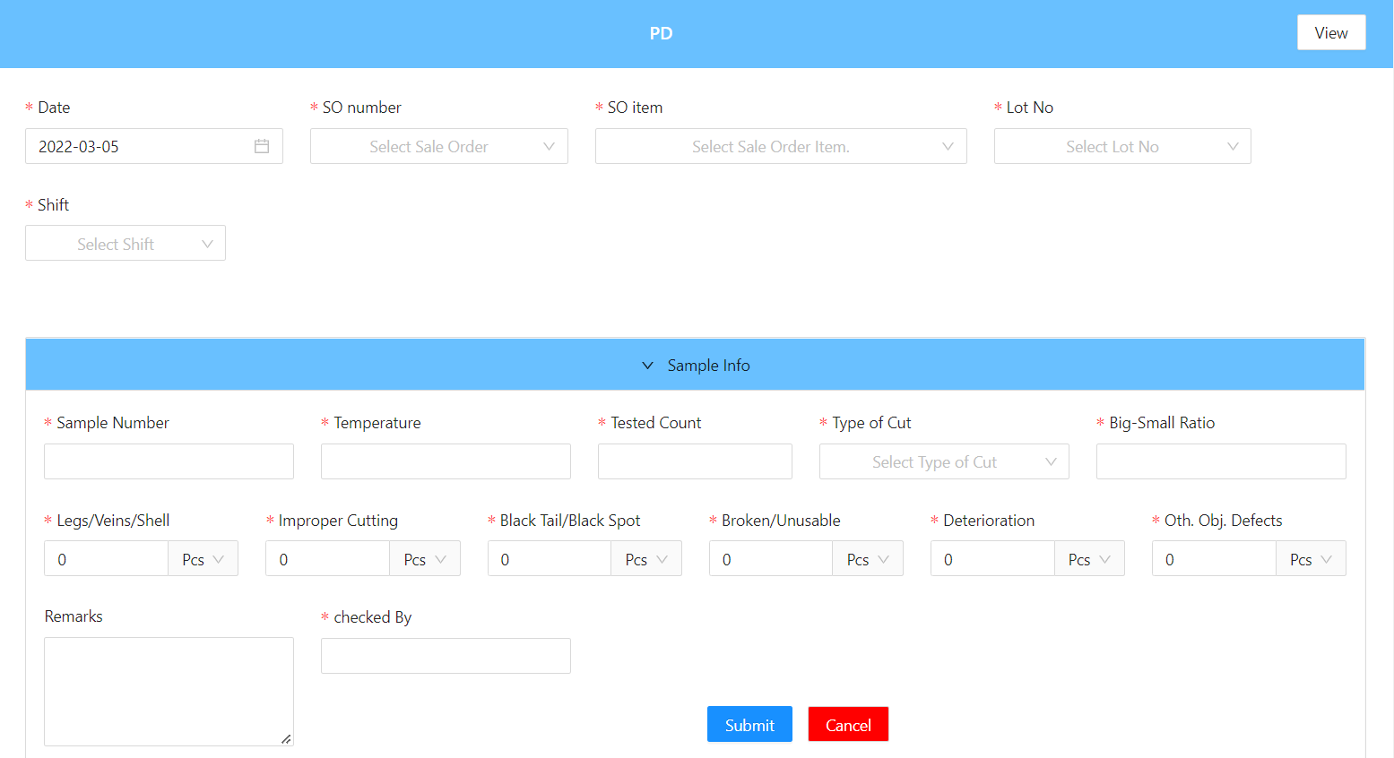

**6)Metal Detection**

**7)So Inspection**

Here we will find the So inspection weather the no of the boxes which are going is perfect count or not.

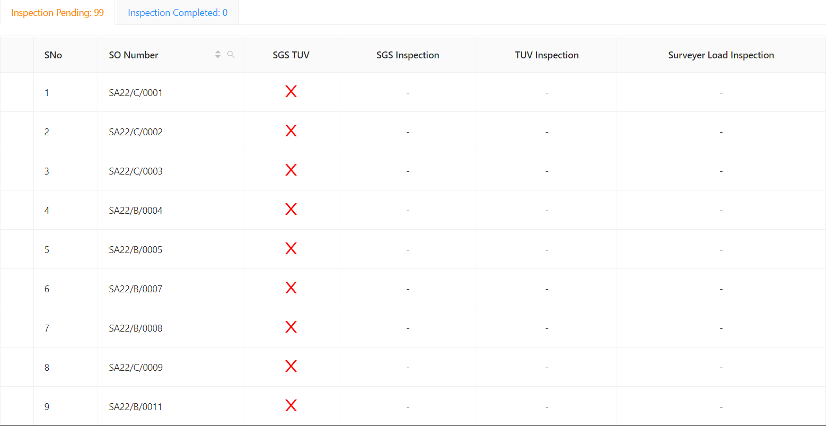

**10) HRMS:**

**1)Leave Management:**

* Here we will find the details of the employees who will apply for the leave and how many day they have been applied

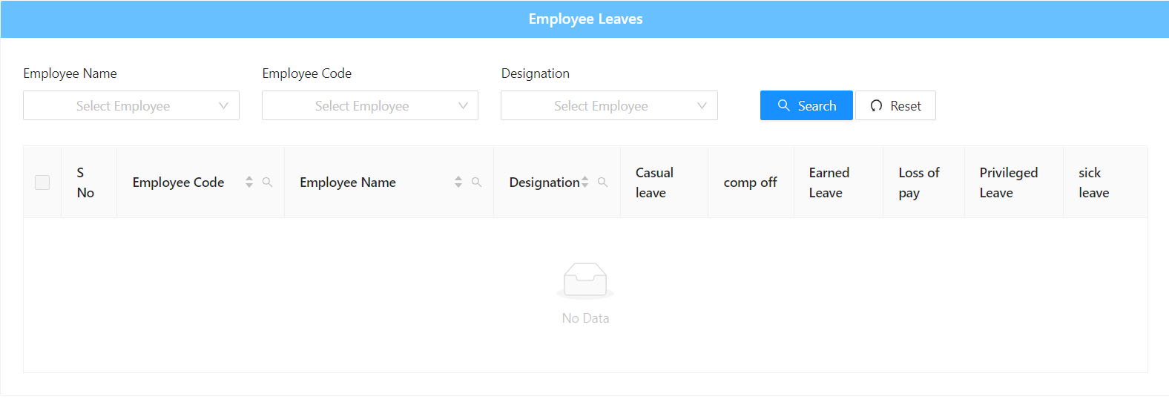

* Here we will apply for the leave using this form.

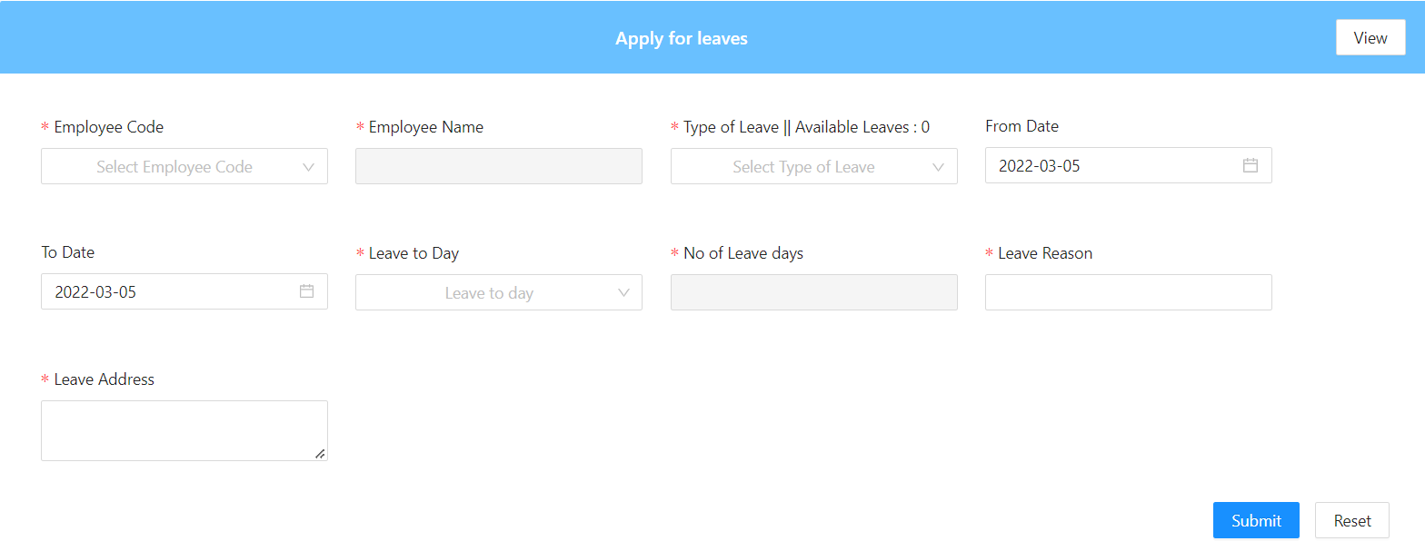

* Here we will approve the leave of the employee.

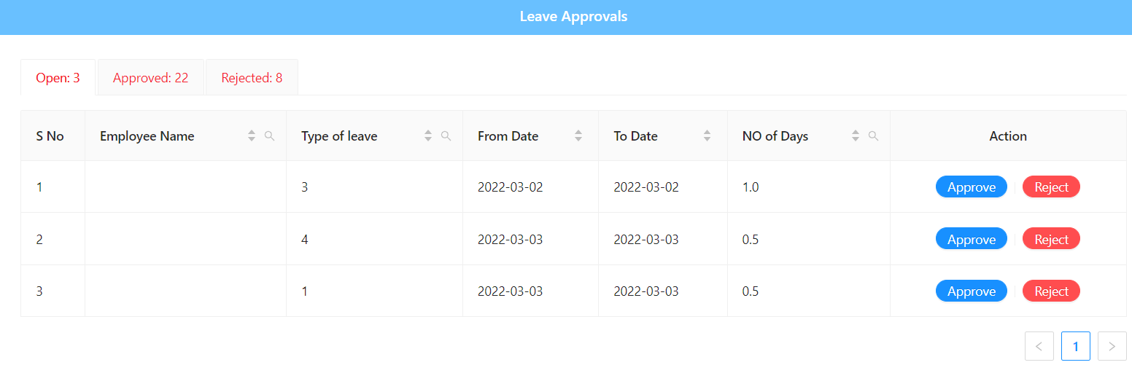

**2)Recruitment:**

* Here we will say when we found the notification for the job here and when the plan is colsed

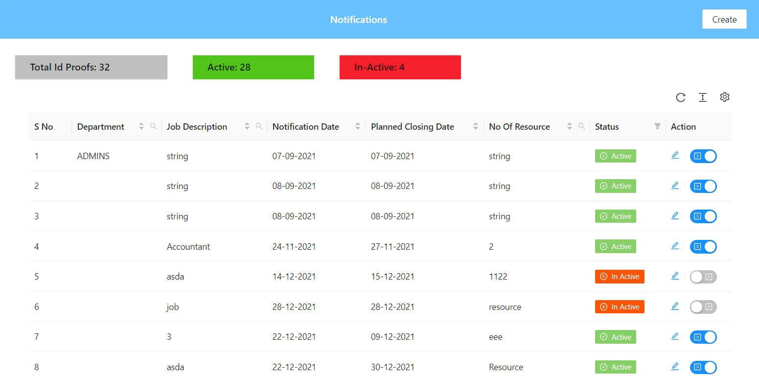

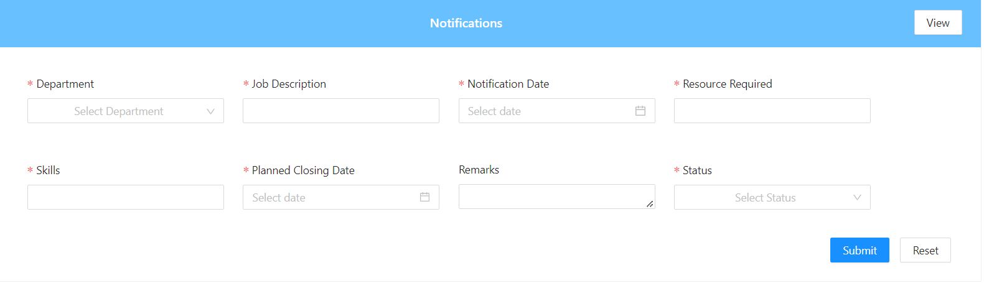

* Here we will find the type of the interview either it is done with hr or any other person in detail.

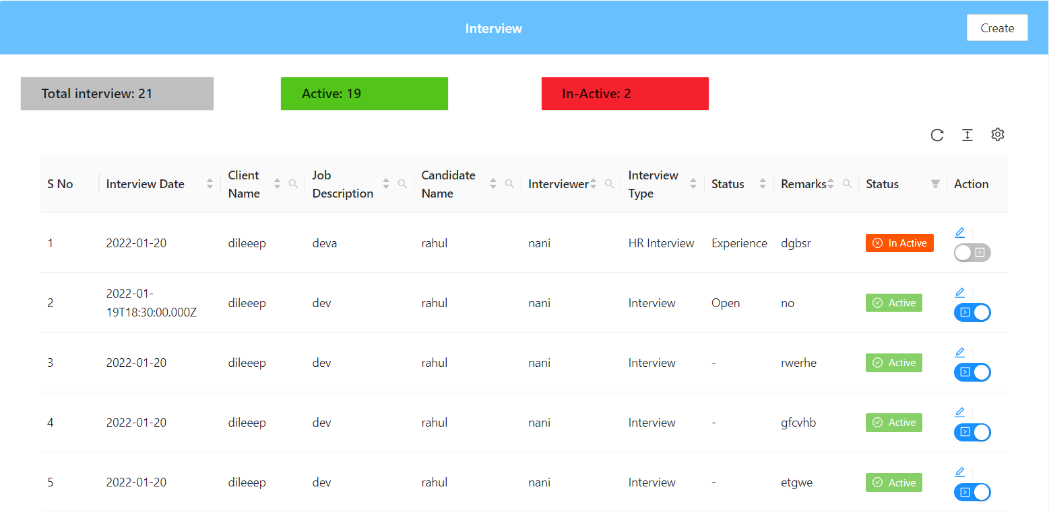

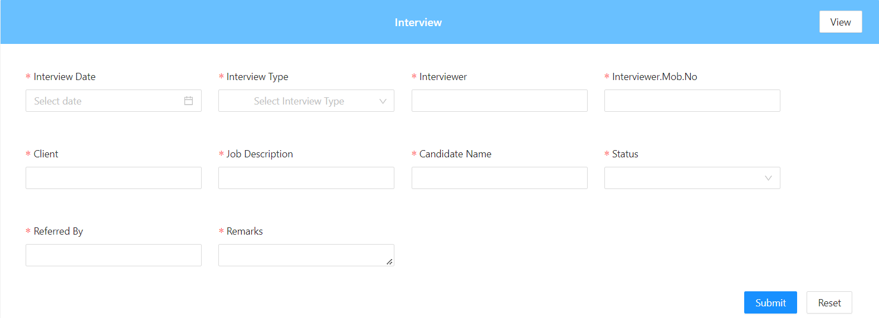

* Here we will see the full profile of the employee who is working in the company.

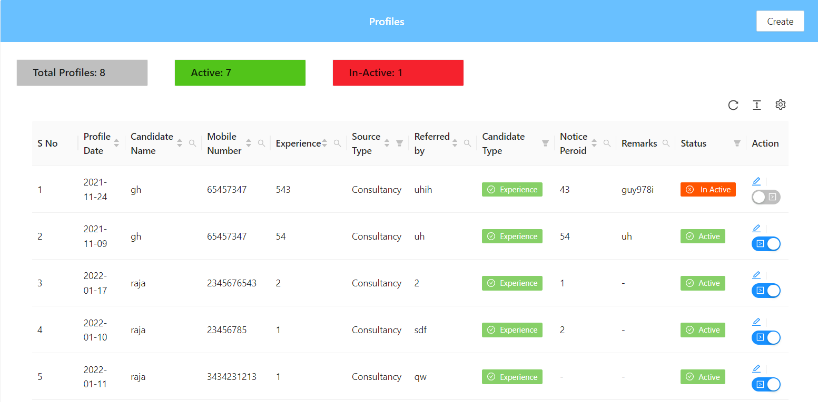

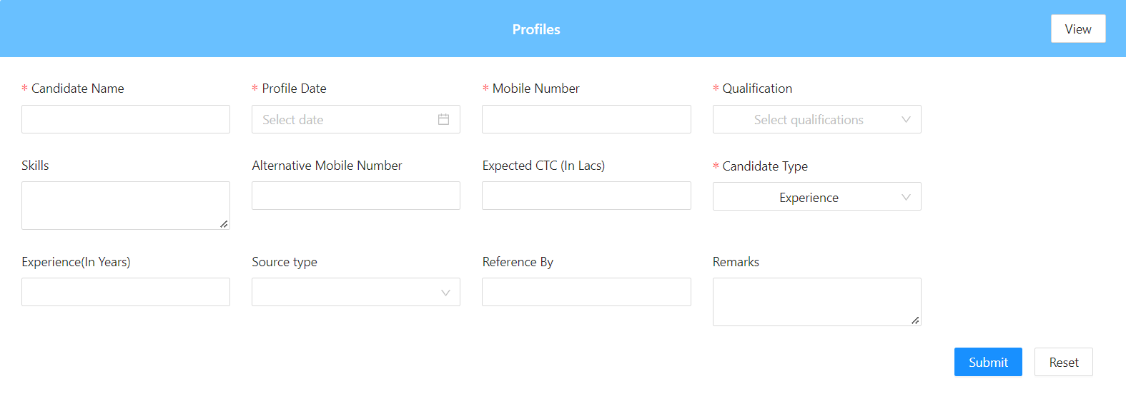

**3)Employee action:**

* Here we will see which employee is in designation and what is the work of each employee.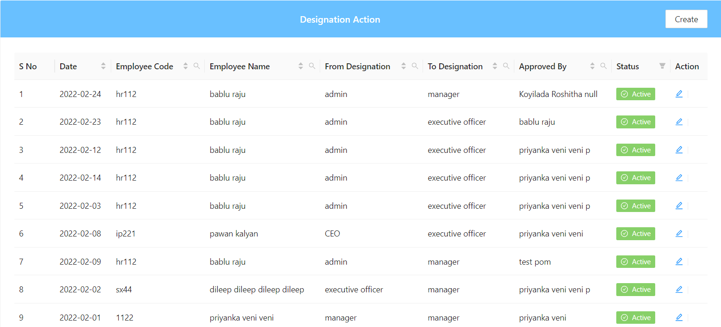

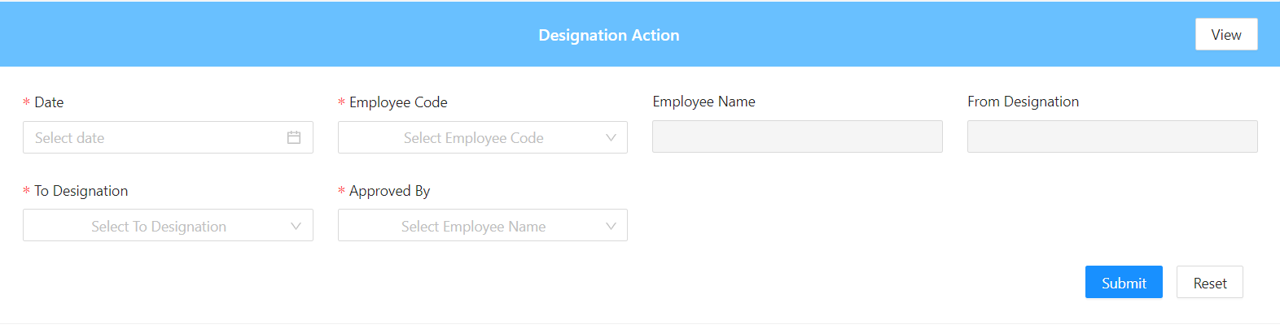

* Here we will see the reason of the employee leaving the company or his or her job.

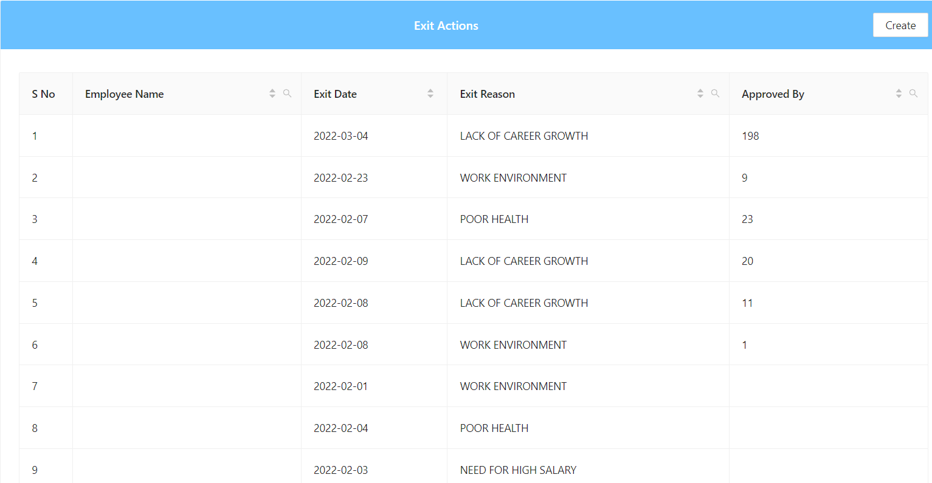

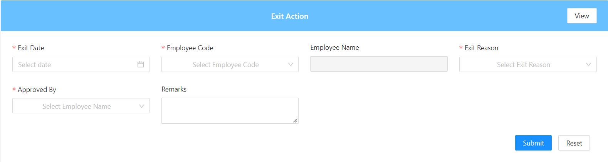

* Here we will find which employee has transferred the details from this plant to other plant or to any others place.

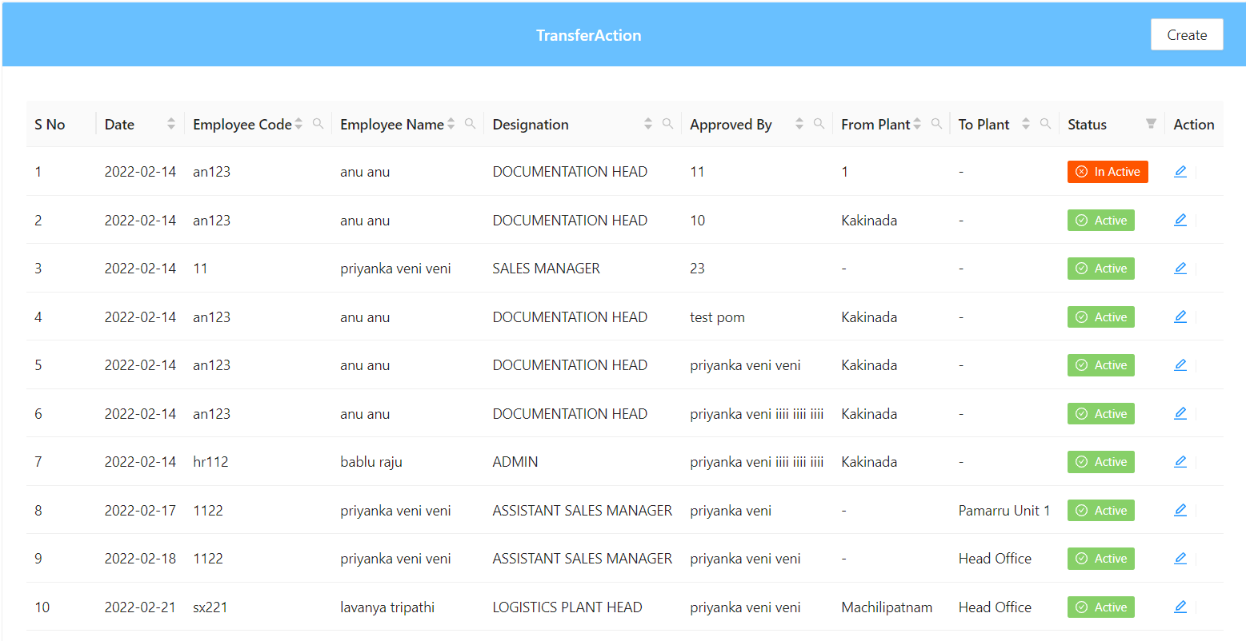

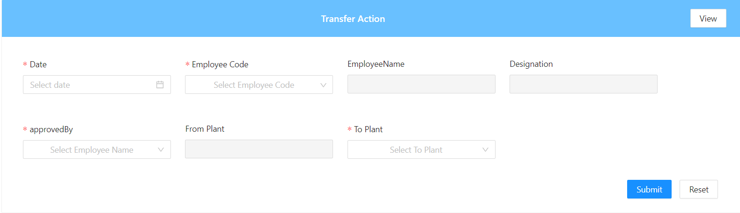

**4)Expenses:**

Here we will see all the expenses which are done by the company and we will find the reason that is it happening like this and what is the use of it.

